APPENDIX

Effectiveness of COVID-19 mRNA primary and booster vaccination during pregnancy: a target trial emulation and meta-analysis of data from 4 European countries

**Table of Contents**

**Appendix Table 1:** Specifications of the target trials. 1

**Appendix Text 1:** Descriptions of the data sources. 1

**Appendix Figure 1:** Study Design Diagram and Propensity Score Covariates. 1

**Appendix Table 2:** Count and percentage of re-enrolled pregnant women across analyses and databases. 1

**Appendix Figure 2:** Flowchart for study populations in the CPRD GOLD database. 1

**Appendix Figure 3:** Flowchart for study populations in the SIDIAP database. 1

**Appendix Figure 4:** Flowchart for study populations in the UiO database. 1

**Appendix Table 3:** Baseline characteristics of the study population in the CPRD GOLD database, for the Primary Vaccination Schema vs. Unvaccinated analysis. 1

**Appendix Table 4:** Baseline characteristics of the study population in the CPRD GOLD database, for the Booster vs. Primary Vaccination Schema analysis. 1

**Appendix Table 5:** Baseline characteristics of the study population in the SCIFI-PEARL database, for the Primary Vaccination Schema vs. Unvaccinated analysis. 1

**Appendix Table 6:** Baseline characteristics of the study population in the SCIFI-PEARL database, for the Booster vs. Primary Vaccination Schema analysis. 1

**Appendix Table 7:** Baseline characteristics of the study population in the SIDIAP database, for the Primary Vaccination Schema vs. Unvaccinated analysis. 1

**Appendix Table 8:** Baseline characteristics of the study population in the SIDIAP database, for the Booster vs. Primary Vaccination Schema analysis. 1

**Appendix Table 9:** Baseline characteristics of the study population in the UiO database, for the Primary Vaccination Schema vs. Unvaccinated analysis. 1

**Appendix Table 10:** Baseline characteristics of the study population in the UiO database, for the Booster vs. Primary Vaccination Schema analysis. 1

**Appendix Table 11:** Additional information on follow-up and reasons for censoring. CPRD GOLD database, for the Primary Vaccination Schema vs. Unvaccinated analysis. 1

**Appendix Table 12:** Additional information on follow-up and reasons for censoring. CPRD GOLD database, for the Booster vs. Primary Vaccination Schema analysis. 1

**Appendix Table 13:** Additional information on follow-up and reasons for censoring. SCIFI-PEARL database, for the Primary Vaccination Schema vs. Unvaccinated analysis. 1

**Appendix Table 14:** Additional information on follow-up and reasons for censoring. SCIFI-PEARL database, for the Booster vs. Primary Vaccination Schema analysis. 1

**Appendix Table 15:** Additional information on follow-up and reasons for censoring. SIDIAP database, for the Primary Vaccination Schema vs. Unvaccinated analysis. 1

**Appendix Table 16:** Additional information on follow-up and reasons for censoring. SIDIAP database, for the Booster vs. Primary Vaccination Schema analysis. 1

**Appendix Table 17:** Additional information on follow-up and reasons for censoring. UiO database, for the Primary Vaccination Schema vs. Unvaccinated analysis. 1

**Appendix Table 18:** Additional information on follow-up and reasons for censoring. UiO database, for the Booster vs. Primary Vaccination Schema analysis. 1

**Appendix Figure 5:** Distribution of index dates (enrollment date) across all databases and analyses. 1

**Appendix Figure 6:** Hazard Ratios for COVID-19 Infection and Hospitalisation (Primary Vaccination Schema vs. Unvaccinated, and Booster vs. Primary Vaccination Schema) stratified by vaccine brand. 1

**Appendix Figure 7:** Kaplan-Meier curves for COVID-19 infection, across databases, and analysis 1

**Appendix Figure 8:** Kaplan-Meier curves for COVID-19-related hospitalisation, across databases, and analysis 1

**Appendix Figure 9:** Log-Log plots for COVID-19 infection, across databases, and analysis 1

**Appendix Figure 10:** Log-Log plots for COVID-19-related hospitalisation, across databases, and analysis 1

**Appendix Figure 11:** Meta-Analysed Hazard Ratio estimates against COVID-19 infection and COVID-19 related hospitalisation across different time-windows post-vaccination. 1

**Appendix Figure 12:** Negative Control Outcomes results for SCIFI-PEARL database. 1

**Appendix Figure 13:** Negative Control Outcomes results for UiO database. 1

**Appendix Figure 14:** Negative Control Outcomes results for SIDIAP database. 1

**Appendix Figure 15:** Negative Control Outcomes results for CPRD GOLD database. 1

**Appendix Figure 16:** Vaccine effectiveness estimates for Primary Vaccination Schema vs. Unvaccinated, when follow-up is not stopped at pregnancy end date. 1

**Appendix Figure 17:** Vaccine effectiveness estimates for Booster vs. Primary Vaccination Schema, when follow-up is not stopped at pregnancy end date. 1

**Appendix Figure 18:** Hazard Ratios for COVID-19 Infection and Hospitalisation (Primary Vaccination Schema vs. Unvaccinated, and Booster vs. Primary Vaccination Schema) stratified by pregnancy trimester at time of vaccination, when follow-up is not stopped at pregnancy end date. 1

**Appendix Figure 19:** Hazard Ratios for COVID-19 Infection and Hospitalisation (Primary Vaccination Schema vs. Unvaccinated, and Booster vs. Primary Vaccination Schema) stratified by vaccine brand, when follow-up is not stopped at pregnancy end date. 1

**Appendix Figure 20:** Hazard Ratios for COVID-19 related Hospitalisation (Primary Vaccination Schema vs. Unvaccinated, and Booster vs. Primary Vaccination Schema), when hospitalisation related to delivery is considered. 1

**Appendix Figure 21:** Vaccine effectiveness estimates for Primary Vaccination Schema vs. Unvaccinated, when COVID-19 records are identified based on polymerase chain reaction (PCR) or antigen postitive tests. 1

**Appendix Figure 22:** Vaccine effectiveness estimates for Booster vs. Primary Vaccination Schema, when COVID-19 records are identified based on polymerase chain reaction (PCR) or antigen postitive tests. 1

## **Appendix Table 1:** Specifications of the target trials.

|  |  |  |
| --- | --- | --- |
| **Protocol component** | **Target trial specification** | **Target trial emulation** |
| **Eligibility criteria** | * Enrolment period: From the start of the vaccination campaign to 90 days prior to end of data availability * Pregnant population (gestational age < 34 weeks) * Aged 12 to 55 years * No prior COVID-19 infection in the 90 days prior * Enrolled in the health care system of interest for at least 12 months prior to pregnancy start. | Same as for the target trial |
| **Treatment strategies** | Primary vaccination vs. unvaccination:   1. Primary vaccination schema (2 doses) initiated during pregnancy: 2. BNT162b2 (gap between doses 17 to 42 days) 3. mRNA-1273 (gap between doses 24 to 49 days) 4. No vaccination   Booster dose vs. primary vaccination:   1. Third dose of BNT162b2 or mRNA-1273 during pregnancy after at least 3 months after the 2n dose. 2. Primary vaccination | Same as for the target trial |
| **Treatment assignment** | Individuals are randomly assigned to a strategy at baseline and will be aware of the strategy to which they have been assigned | Individuals are classified according to the strategy with which their data are compatible at baseline. Randomisation is emulated by adjusting for baseline confounders. |
| **Outcomes** | * SARS-CoV-2 infection * COVID-19-related hospitalisation * COVID-19-related ICU admission | Same as for the target trial |
| **Follow-up** | * Starts at treatment assignment * Ends at the first of: outcome occurrence, loss of follow-up, end of data availability or deviation from the treatment assigned at baseline. | Same as for the target trial |
| **Causal contrast** | Per-protocol effect | Same as for the target trial |
| **Statistical analyses** | Per-protocol analysis: censor participants when they deviate from their assigned treatment strategy. | Same as for the target trial |

## **Appendix Text 1:** Descriptions of the data sources.

This network study was conducted using four routine healthcare databases with complete vaccination coverage from the UK, Sweden, Spain and Norway. All databases were previously mapped to the Observational Medical Outcomes Partnership (OMOP) Common Data Model, which allowed a federated approach. Data cut for all participating databases was between 2023 and 2024 (CPRD GOLD: 23-06-2023; SCIFI-PEARL: 30-08-2024; SIDIAP: 30-06-2023; UiO: 31-12-2023).

Clinical Practice Research Datalink (CPRD) GOLD, UK:

The Clinical Practice Research Datalink (CPRD) is a governmental, not-for-profit research service, jointly funded by the National Institute for Health and Care Research and the Medicines and Healthcare products Regulatory Agency, a part of the Department of Health and Social Care (https://cprd.com). CPRD collects anonymised patient data from a network of GP practices across the UK.(1) It contains of all clinical and referral events in primary care in addition to comprehensive demographic information and medication prescription. Data from contributing practices are collected and processed into research databases. Data are available for 20 million patients. Pregnancy episodes in CPRD were inferred using a previously validated algorithm, which was validated for CPRD data mapped to the OMOP common data model.(2)

Swedish Covid-19 Investigation for Future Insights – a Population Epidemiology Approach using Register Linkage (SCIFI-PEARL), Sweden:

Swedish data was obtained through the Swedish Covid-19 Investigation for Future Insights – a Population Epidemiology Approach using Register Linkage (SCIFI-PEARL) project. The study population covers the full Swedish population since 2015 and links from multiples using the unique Swedish personal identification number. Data mapped to OMOP common data model include high-quality data on specialist outpatient care and inpatient care from the National Patient Register (3), intensive care from the Swedish Intensive Care Register (4), mortality data from the National Cause-of-death Register (5), medication information from the National Prescribed Drug Register (6), SARS-CoV-2 test positive records from the National monitoring system for communicable diseases (SmiNet) (7), COVID-19 vaccination data from the National Vaccination Register.(3-7) It also includes demographics from the Total Population Register, socioeconomic information from the Longitudinal integrated database for health insurance and labour market studies (LISA) and more.(8,9) Primary care data is available for 40% of patients only. Additionally, OMOP mapped data from the National Medical Birth Register is also included, with information on mother and child, with a national coverage of about 100,000 births per year.(10)

Information System for Research in Primary Care (SIDIAP), Spain:

The Information System for Research in Primary Care (SIDIAP; www.sidiap.org) database in Catalonia (SIDIAP) contains pseudo-anonymised electronic health records since 2006 for 8 million people (75% of the Catalan population) and is representative of the general population in terms of age, sex, and geographic distribution.(11) SIDIAP includes high-quality data registered by healthcare professionals on sociodemographic, disease diagnoses, anthropometric measurements, vaccine administration, prescription, and dispensation of drugs, among others. The database includes detailed pregnancy information such as dates of last period and of estimated delivery, along with the type of delivery, the circumstance of the end of the pregnancy (e.g. type of delivery, abortion, etc.), gestational age and trimestral obstetric ultrasounds, among others. SIDIAP has been linked to SARS-CoV-2 Reverse Transcription Polymerase Chain Reaction (RT-PCR) test results, hospital discharge records (CMBD, Conjunto Mínimo Básico de Datos), and regional mortality data.

Norwegian Linked Health Registries, Norway:

Data from Norway was obtained from the Norwegian Linked Health Registries at the University of Oslo (UiO), which contains data from Norwegian health care administrative databases that cover the entire Norwegian population from 2008 to 2023. The data that UiO mapped onto the OMOP CDM includes high-quality data on disease diagnoses from primary and secondary care, drug dispensations, vaccine administration, positive tests for communicable diseases, demographic characteristics, among others from the Norwegian Prescribed Drug Register (LMR), the national vaccination registry (SYSVAK), the Norwegian Surveillance System for Communicable Diseases (MSIS) , Norwegian Control and Payment of Health Reimbursements Database (KUHR), and the Norwegian Patient Registry (NPR).(12-14) Importantly, it includes detailed information related to all pregnancies in Norway (information on the mother, father, and child), approximately 60,000 deliveries per year from the Medical Birth Registry of Norway (MBRN)(15). The MBRN contains all pregnancies with more than 12 week duration. For this study, we have used an algorithm developed by the UiO that allows the identification of pregnancies during the first 12 weeks of gestation.

References:

1. Herrett E, Gallagher AM, Bhaskaran K, Forbes H, Mathur R, Van Staa T, et al. Data Resource Profile: Clinical Practice Research Datalink (CPRD). International Journal of Epidemiology. 2015;44(3):827-36.
2. Matcho A, Ryan P, Fife D, Gifkins D, Knoll C, Friedman A. Inferring pregnancy episodes and outcomes within a network of observational databases. PLOS ONE. 2018;13(2):e0192033.
3. National Board of Health and Welfare (Socialstyrelsen). National Patient Register. https://www.socialstyrelsen.se/en/statistics-and-data/registers/national-patient-register/ (accessed 27 Jun 2024)
4. The Swedish Intensive Care. https://www.icuregswe.org/en (accessed 27 Jun 2024)
5. National Board of Health and Welfare (Socialstyrelsen).  National Cause of Death Register. https://www.socialstyrelsen.se/en/statistics-and-data/registers/national-cause-of-death--register/ (accessed 27 Jun 2024)
6. National Board of Health and Welfare (Socialstyrelsen).  National Prescribed Drug Register. https://www.socialstyrelsen.se/en/statistics-and-data/registers/national-prescribed-drug-register/ (accessed 27 Jun 2024)
7. National monitoring system for communicable diseases. https://www.folkhalsomyndigheten.se/sminet/ (accessed 27 Jun 2024)
8. Statistics Sweden. Data från Registret över totalbefolkningen (RTB). https://www.scb.se/vara-tjanster/bestall-data-och-statistik/register/registret-over-totalbefolkningen-rtb/ (accessed 27 Jun 2024)
9. Statistics Sweden. Longitudinal integrated database for health insurance and labour market studies (LISA). https://www.scb.se/en/services/ordering-data-and-statistics/register/longitudinal-integrated-database-for-health-insurance-and-labour-market-studies-lisa/ (accessed 27 Jun 2024)
10. National Board of Health and Welfare (Socialstyrelsen).  National Medical Birth Register. https://www.socialstyrelsen.se/en/statistics-and-data/registers/national-medical-birth-register/ (accessed 27 Jun 2024)
11. Recalde M, Rodríguez C, Burn E, Far M, García D, Carrere-Molina J, et al. Data Resource Profile: The Information System for Research in Primary Care (SIDIAP). Int J Epidemiol. 2022 Dec 13;51(6):e324–36.
12. Norwegian Prescription Database (NorPD) - NIPH. https://www.fhi.no/en/he/norpd/ (accessed 6 Jul 2023).
13. Norwegian Immunisation Registry SYSVAK - NIPH. https://www.fhi.no/en/va/norwegian-immunisation-registry-sysvak/ (accessed 6 Jul 2023).
14. Norwegian Surveillance System for Communicable Diseases (MSIS) - NIPH. https://www.fhi.no/en/ou/msis/ (accessed 6 Jul 2023).
15. Norwegian Patient Registry (NPR). https://helsedata.no/en/forvaltere/norwegian-directorate-of-health/norwegian-patient-registry-npr/ (accessed 6 Jul 2023).
16. Medical Birth Registry of Norway - NIPH. https://www.fhi.no/en/ch/medical-birth-registry-of-norway/ (accessed 6 Jul 2023).
17. Nordeng H, Lupattelli A, Hilde, Marleen. Detecting and Dating Early Non‐live Pregnancy Outcomes: Generation of a Novel Pregnancy Algorithm From Norwegian Linked Health Registries. Pharmacoepidemiology and Drug Safety. 2024;33(9).

## **Appendix Figure 1:** Study Design Diagram and Propensity Score Covariates.

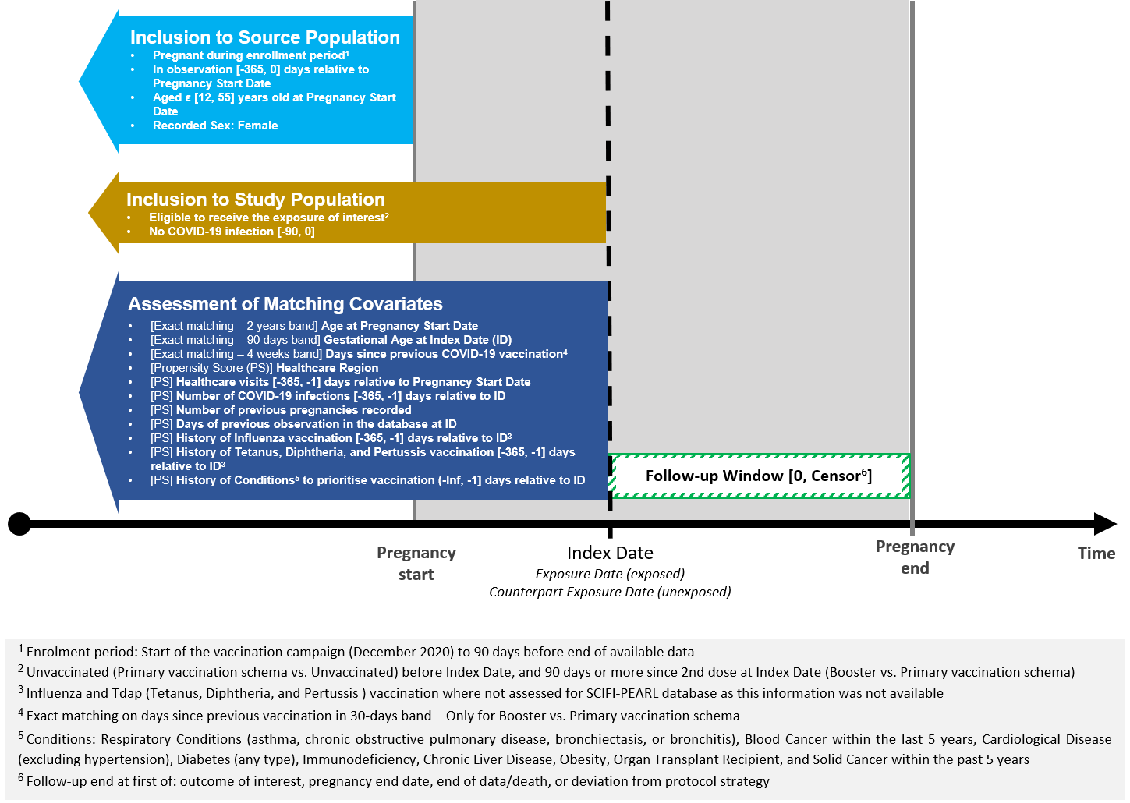

## **Appendix Table 2:** Count and percentage of re-enrolled pregnant women across analyses and databases.

| **Analysis** | **CDM name** | **N (%)** |
| --- | --- | --- |
| **Booster vs. Primary Vaccination Schema** | CPRD GOLD | 333 (9.65%) |
| SCIFI-PEARL | 7126 (15.74%) |
| SIDIAP | 316 (7.67%) |
| UiO | 2760 (14.66%) |
| **Primary Vaccination Schema vs. Unvaccinated** | CPRD GOLD | 561 (11.4%) |
| SCIFI-PEARL | 10920 (17.65%) |
| SIDIAP | 2205 (17.29%) |
| UiO | 4907 (18.89%) |

## **Appendix Figure 2:** Flowchart for study populations in the CPRD GOLD database.

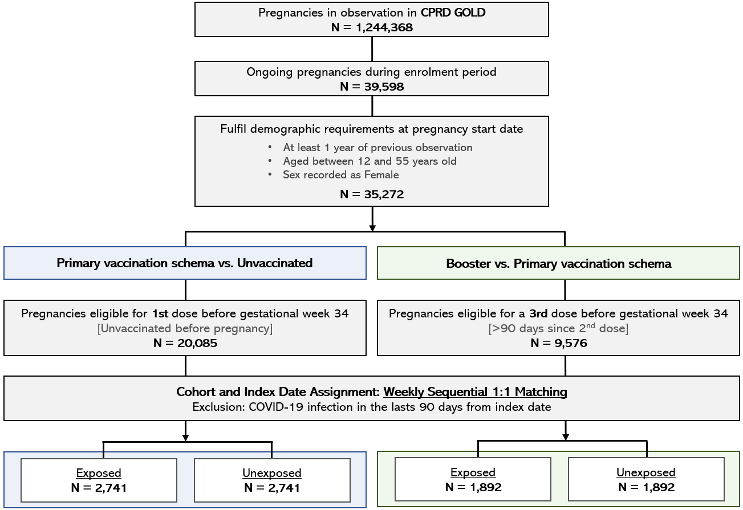

## **Appendix Figure 3:** Flowchart for study populations in the SIDIAP database.

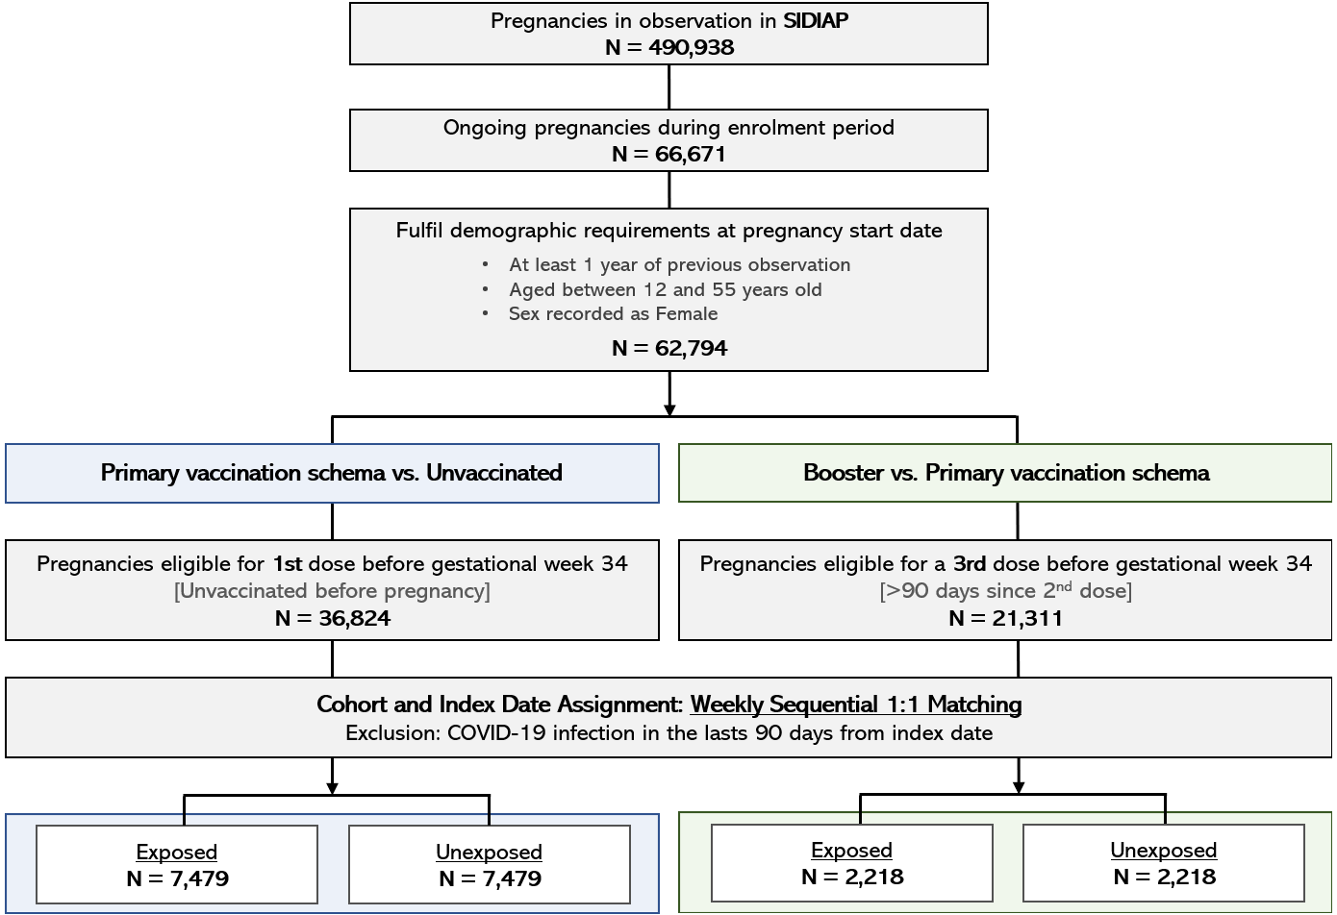

## **Appendix Figure 4:** Flowchart for study populations in the UiO database.

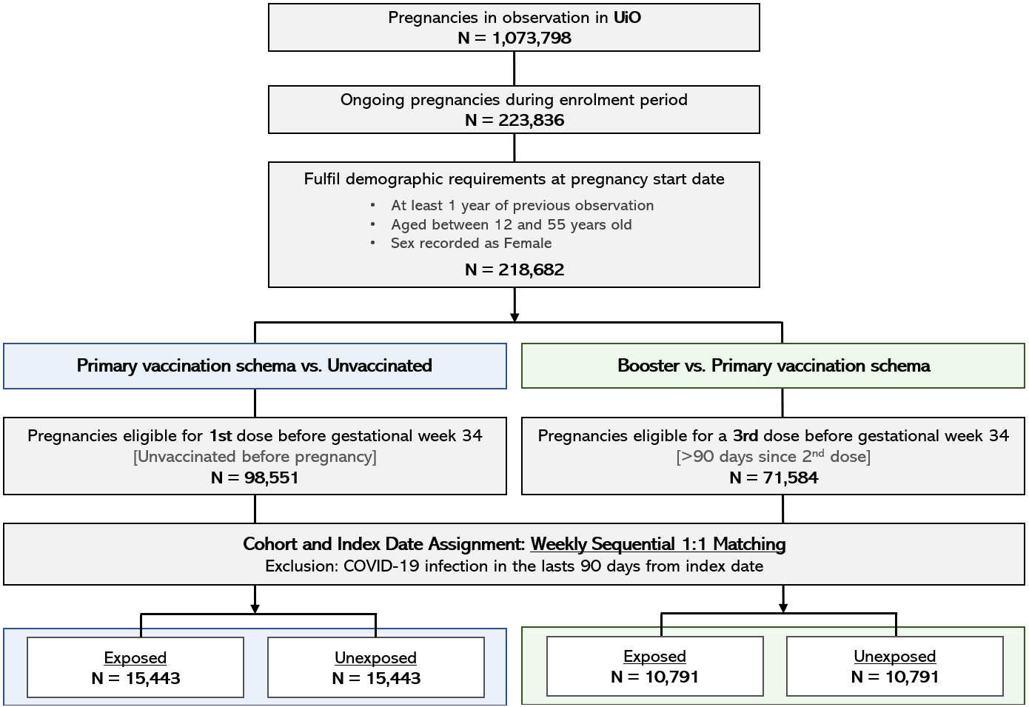

## **Appendix Table 3:** Baseline characteristics of the study population in the CPRD GOLD database, for the Primary Vaccination Schema vs. Unvaccinated analysis.

| **Covariate** | **Covariate level** | **Estimate** | **Cohort** | |
| --- | --- | --- | --- | --- |
| **Unexposed** | **Exposed** |
| **Age (Years)** | - | Median (Q25 - Q75) | 32.00 (28.00 - 35.00) | 32.00 (28.00 - 35.00) |
| **Age Group** | 12 to 24 | N (%) | 272 (9.9%) | 265 (9.7%) |
| 25 to 39 | N (%) | 2,318 (84.6%) | 2,331 (85.0%) |
| 40 to 55 | N (%) | 151 (5.5%) | 145 (5.3%) |
| **Gestational Trimester** | T1 | N (%) | 1,107 (40.4%) | 1,107 (40.4%) |
| T2 | N (%) | 954 (34.8%) | 954 (34.8%) |
| T3 | N (%) | 680 (24.8%) | 680 (24.8%) |
| **Vaccine Product** | Moderna | N (%) | - | 280 (10.2%) |
| Pfizer | N (%) | - | 2,461 (89.8%) |
| **Previous Pregnancies** | - | Median (Q25 - Q75) | 2.00 (2.00 - 2.00) | 2.00 (2.00 - 2.00) |
| **Healthcare Visits (Past Year)** | - | Median (Q25 - Q75) | 20.00 (11.00 - 38.00) | 24.00 (14.00 - 42.00) |
| **Days of Prior Observation** | - | Median (Q25 - Q75) | 3,290 (1,394 - 6,545) | 3,020 (1,344 - 6,577) |
| **COVID-19 Infection (Any Time Prior)** | - | Median (Q25 - Q75) | 0.00 (0.00 - 0.00) | 0.00 (0.00 - 0.00) |
| **Other Vaccinations (Any Time Prior)** | Tdap | N (%) | 1,439 (52.5%) | 1,562 (57.0%) |
| Influenza | N (%) | 830 (30.3%) | 964 (35.2%) |
| **Comorbidities (Any Time Prior)** | PCOS | N (%) | 64 (2.3%) | 62 (2.3%) |
| Venous thromboembolism | N (%) | 11 (0.4%) | 7 (0.3%) |
| Anemia | N (%) | 114 (4.2%) | 120 (4.4%) |
| Pregnancy induced hypertension | N (%) | 12 (0.4%) | 20 (0.7%) |
| Renal impairment | N (%) | 2 (0.1%) | 2 (0.1%) |
| Stroke | N (%) | 2 (0.1%) | 0 (0.0%) |
| Chronic hypertension | N (%) | 28 (1.0%) | 30 (1.1%) |
| Heart conditions | N (%) | 12 (0.4%) | 23 (0.8%) |
| Hypothyroidism | N (%) | 64 (2.3%) | 73 (2.7%) |
| Anxiety disorder | N (%) | 229 (8.4%) | 185 (6.7%) |
| Depressive disorder | N (%) | 444 (16.2%) | 372 (13.6%) |
| Diabetes (any type) | N (%) | 94 (3.4%) | 110 (4.0%) |
| Interstitial lung disease | N (%) | 0 (0.0%) | 1 (0.0%) |
| Asthma | N (%) | 173 (6.3%) | 212 (7.7%) |
| Pneumonia | N (%) | 12 (0.4%) | 12 (0.4%) |
| HIV | N (%) | 0 (0.0%) | 0 (0.0%) |
| **Medications Prescribed (Last 180 Days)** | Estrogens | N (%) | 17 (0.6%) | 21 (0.8%) |
| Drugs ulcer and gords | N (%) | 244 (8.9%) | 257 (9.4%) |
| Antiinflammatory antirehumatic | N (%) | 151 (5.5%) | 136 (5.0%) |
| Corticosteroids | N (%) | 20 (0.7%) | 30 (1.1%) |
| Antithrombotics | N (%) | 33 (1.2%) | 33 (1.2%) |
| Antihistamines systemic | N (%) | 422 (15.4%) | 436 (15.9%) |
| Antidepressants | N (%) | 419 (15.3%) | 423 (15.4%) |
| Progestogens | N (%) | 84 (3.1%) | 86 (3.1%) |
| Antimycotics systemic | N (%) | 22 (0.8%) | 15 (0.5%) |
| Immunosupressants | N (%) | 2 (0.1%) | 3 (0.1%) |
| Antiepileptics | N (%) | 52 (1.9%) | 37 (1.3%) |
| Antibacterials systemic | N (%) | 567 (20.7%) | 512 (18.7%) |
| Analgesics and antipyretics | N (%) | 260 (9.5%) | 279 (10.2%) |
|  | - | N | - | 2,741 |

## **Appendix Table 4:** Baseline characteristics of the study population in the CPRD GOLD database, for the Booster vs. Primary Vaccination Schema analysis.

| **Covariate** | **Covariate level** | **Estimate** | **Cohort** | |
| --- | --- | --- | --- | --- |
| **Unexposed** | **Exposed** |
| **Age (Years)** | - | Median (Q25 - Q75) | 32.00 (29.00 - 35.00) | 32.00 (29.00 - 35.00) |
| **Age Group** | 12 to 24 | N (%) | 109 (5.8%) | 104 (5.5%) |
| 25 to 39 | N (%) | 1,713 (90.5%) | 1,714 (90.6%) |
| 40 to 55 | N (%) | 70 (3.7%) | 74 (3.9%) |
| **Gestational Trimester** | T1 | N (%) | 894 (47.3%) | 894 (47.3%) |
| T2 | N (%) | 712 (37.6%) | 712 (37.6%) |
| T3 | N (%) | 286 (15.1%) | 286 (15.1%) |
| **Vaccine Product** | Moderna | N (%) | - | 668 (35.3%) |
| Pfizer | N (%) | - | 1,224 (64.7%) |
| **Previous Pregnancies** | - | Median (Q25 - Q75) | 2.00 (2.00 - 2.00) | 2.00 (2.00 - 2.00) |
| **Healthcare Visits (Past Year)** | - | Median (Q25 - Q75) | 28.00 (16.00 - 44.00) | 30.00 (18.00 - 46.00) |
| **Days of Prior Observation** | - | Median (Q25 - Q75) | 3,340 (1,441 - 6,708) | 2,768 (1,218 - 6,664) |
| **COVID-19 Infection (Any Time Prior)** | - | Median (Q25 - Q75) | 0.00 (0.00 - 0.00) | 0.00 (0.00 - 0.00) |
| **Other Vaccinations (Any Time Prior)** | Tdap | N (%) | 1,000 (52.9%) | 995 (52.6%) |
| Influenza | N (%) | 655 (34.6%) | 665 (35.1%) |
| **Comorbidities (Any Time Prior)** | PCOS | N (%) | 49 (2.6%) | 59 (3.1%) |
| Venous thromboembolism | N (%) | 11 (0.6%) | 8 (0.4%) |
| Anemia | N (%) | 89 (4.7%) | 71 (3.8%) |
| Pregnancy induced hypertension | N (%) | 12 (0.6%) | 12 (0.6%) |
| Renal impairment | N (%) | 4 (0.2%) | 7 (0.4%) |
| Stroke | N (%) | 1 (0.1%) | 2 (0.1%) |
| Chronic hypertension | N (%) | 30 (1.6%) | 25 (1.3%) |
| Heart conditions | N (%) | 19 (1.0%) | 10 (0.5%) |
| Hypothyroidism | N (%) | 46 (2.4%) | 51 (2.7%) |
| Anxiety disorder | N (%) | 124 (6.6%) | 110 (5.8%) |
| Depressive disorder | N (%) | 293 (15.5%) | 228 (12.1%) |
| Diabetes (any type) | N (%) | 61 (3.2%) | 70 (3.7%) |
| Interstitial lung disease | N (%) | 0 (0.0%) | 0 (0.0%) |
| Asthma | N (%) | 131 (6.9%) | 145 (7.7%) |
| Pneumonia | N (%) | 6 (0.3%) | 8 (0.4%) |
| HIV | N (%) | 0 (0.0%) | 0 (0.0%) |
| **Medications Prescribed (Last 180 Days)** | Estrogens | N (%) | 15 (0.8%) | 10 (0.5%) |
| Drugs ulcer and gords | N (%) | 194 (10.3%) | 164 (8.7%) |
| Antiinflammatory antirehumatic | N (%) | 109 (5.8%) | 78 (4.1%) |
| Corticosteroids | N (%) | 32 (1.7%) | 28 (1.5%) |
| Antithrombotics | N (%) | 21 (1.1%) | 27 (1.4%) |
| Antihistamines systemic | N (%) | 351 (18.6%) | 297 (15.7%) |
| Antidepressants | N (%) | 305 (16.1%) | 283 (15.0%) |
| Progestogens | N (%) | 52 (2.7%) | 60 (3.2%) |
| Antimycotics systemic | N (%) | 20 (1.1%) | 16 (0.8%) |
| Immunosupressants | N (%) | 7 (0.4%) | 4 (0.2%) |
| Antiepileptics | N (%) | 34 (1.8%) | 32 (1.7%) |
| Antibacterials systemic | N (%) | 427 (22.6%) | 392 (20.7%) |
| Analgesics and antipyretics | N (%) | 180 (9.5%) | 190 (10.0%) |
|  | - | N | - | 1,892 |

## **Appendix Table 5:** Baseline characteristics of the study population in the SCIFI-PEARL database, for the Primary Vaccination Schema vs. Unvaccinated analysis.

| **Covariate** | **Covariate level** | **Estimate** | **Cohort** | |
| --- | --- | --- | --- | --- |
| **Unexposed** | **Exposed** |
| **Age (Years)** | - | Median (Q25 - Q75) | 31 (28 - 35) | 31 (28 - 35) |
| **Age Group** | 12 to 24 | N (%) | 2,353 (6.5%) | 2,328 (6.4%) |
| 25 to 39 | N (%) | 32,407 (89.0%) | 32,427 (89.1%) |
| 40 to 55 | N (%) | 1,638 (4.5%) | 1,643 (4.5%) |
| **Gestational Trimester** | T1 | N (%) | 9,441 (25.9%) | 9,441 (25.9%) |
| T2 | N (%) | 18,782 (51.6%) | 18,782 (51.6%) |
| T3 | N (%) | 8,175 (22.5%) | 8,175 (22.5%) |
| **Vaccine Product** | Moderna | N (%) | - | 7,348 (20.2%) |
| Pfizer | N (%) | - | 29,050 (79.8%) |
| **Previous Pregnancies** | - | Median (Q25 - Q75) | 1.00 (1.00 - 2.00) | 2.00 (2.00 - 2.00) |
| **Healthcare Visits (Past Year)** | - | Median (Q25 - Q75) | 4.00 (1.00 - 14.00) | 8.00 (2.00 - 22.00) |
| **Days of Prior Observation** | - | Median (Q25 - Q75) | 2,378 (2,338 - 2,413) | 2,379 (2,344 - 2,416) |
| **COVID-19 Infection (Any Time Prior)** | - | Median (Q25 - Q75) | 0.00 (0.00 - 0.00) | 0.00 (0.00 - 0.00) |
| **Comorbidities (Any Time Prior)** | Chronic hypertension | N (%) | 995 (2.7%) | 1,267 (3.5%) |
| Heart conditions | N (%) | 388 (1.1%) | 474 (1.3%) |
| Pneumonia | N (%) | 565 (1.6%) | 499 (1.4%) |
| Venous thromboembolism | N (%) | 188 (0.5%) | 193 (0.5%) |
| Anxiety disorder | N (%) | 4,483 (12.3%) | 4,908 (13.5%) |
| Stroke | N (%) | 25 (0.1%) | 27 (0.1%) |
| Anemia | N (%) | 3,535 (9.7%) | 2,978 (8.2%) |
| Diabetes (any type) | N (%) | 463 (1.3%) | 563 (1.5%) |
| Hypothyroidism | N (%) | 1,640 (4.5%) | 1,693 (4.7%) |
| Asthma | N (%) | 1,502 (4.1%) | 1,778 (4.9%) |
| PCOS | N (%) | 1,250 (3.4%) | 1,235 (3.4%) |
| Depressive disorder | N (%) | 3,265 (9.0%) | 3,521 (9.7%) |
| HIV | N (%) | 17 (0.0%) | 15 (0.0%) |
| Interstitial lung disease | N (%) | 35 (0.1%) | 36 (0.1%) |
| Renal impairment | N (%) | 57 (0.2%) | 77 (0.2%) |
| Pregnancy induced hypertension | N (%) | 730 (2.0%) | 921 (2.5%) |
| **Medications Prescribed (Last 180 Days)** | Antithrombotics | N (%) | 590 (1.6%) | 620 (1.7%) |
| Immunosupressants | N (%) | 167 (0.5%) | 234 (0.6%) |
| Progestogens | N (%) | 2,605 (7.2%) | 2,917 (8.0%) |
| Estrogens | N (%) | 1,461 (4.0%) | 1,711 (4.7%) |
| Antimycotics systemic | N (%) | 466 (1.3%) | 443 (1.2%) |
| Antidepressants | N (%) | 2,529 (6.9%) | 3,427 (9.4%) |
| Analgesics and antipyretics | N (%) | 5,043 (13.9%) | 5,450 (15.0%) |
| Corticosteroids | N (%) | 592 (1.6%) | 639 (1.8%) |
| Antihistamines systemic | N (%) | 7,469 (20.5%) | 7,985 (21.9%) |
| Antibacterials systemic | N (%) | 3,667 (10.1%) | 3,333 (9.2%) |
| Drugs ulcer and gords | N (%) | 1,964 (5.4%) | 1,846 (5.1%) |
| Antiepileptics | N (%) | 244 (0.7%) | 310 (0.9%) |
| Antiinflammatory antirehumatic | N (%) | 1,337 (3.7%) | 1,326 (3.6%) |

## **Appendix Table 6:** Baseline characteristics of the study population in the SCIFI-PEARL database, for the Booster vs. Primary Vaccination Schema analysis.

| **Covariate** | **Covariate level** | **Estimate** | **Cohort** | |
| --- | --- | --- | --- | --- |
| **Unexposed** | **Exposed** |
| **Age (Years)** | - | Median (Q25 - Q75) | 31 (29 - 34) | 31 (29 - 34) |
| **Age Group** | 12 to 24 | N (%) | 1,121 (4.3%) | 1,085 (4.1%) |
| 25 to 39 | N (%) | 24,203 (92.4%) | 24,244 (92.6%) |
| 40 to 55 | N (%) | 871 (3.3%) | 866 (3.3%) |
| **Gestational Trimester** | T1 | N (%) | 5,558 (21.2%) | 5,558 (21.2%) |
| T2 | N (%) | 15,411 (58.8%) | 15,411 (58.8%) |
| T3 | N (%) | 5,226 (20.0%) | 5,226 (20.0%) |
| **Vaccine Product** | Moderna | N (%) | - | 5,008 (19.1%) |
| Pfizer | N (%) | - | 21,187 (80.9%) |
| **Previous Pregnancies** | - | Median (Q25 - Q75) | 2.00 (1.00 - 2.00) | 2.00 (2.00 - 2.00) |
| **Healthcare Visits (Past Year)** | - | Median (Q25 - Q75) | 4.00 (0.00 - 15.00) | 6.00 (0.00 - 20.00) |
| **Days of Prior Observation** | - | Median (Q25 - Q75) | 2,591 (2,572 - 2,659) | 2,592 (2,574 - 2,665) |
| **COVID-19 Infection (Any Time Prior)** | - | Median (Q25 - Q75) | 0.00 (0.00 - 0.00) | 0.00 (0.00 - 0.00) |
| **Comorbidities (Any Time Prior)** | Chronic hypertension | N (%) | 895 (3.4%) | 870 (3.3%) |
| Heart conditions | N (%) | 286 (1.1%) | 362 (1.4%) |
| Pneumonia | N (%) | 370 (1.4%) | 366 (1.4%) |
| Venous thromboembolism | N (%) | 123 (0.5%) | 131 (0.5%) |
| Anxiety disorder | N (%) | 3,427 (13.1%) | 3,598 (13.7%) |
| Stroke | N (%) | 18 (0.1%) | 19 (0.1%) |
| Anemia | N (%) | 2,156 (8.2%) | 1,922 (7.3%) |
| Diabetes (any type) | N (%) | 330 (1.3%) | 341 (1.3%) |
| Hypothyroidism | N (%) | 1,111 (4.2%) | 1,154 (4.4%) |
| Asthma | N (%) | 1,081 (4.1%) | 1,310 (5.0%) |
| PCOS | N (%) | 927 (3.5%) | 879 (3.4%) |
| Depressive disorder | N (%) | 2,415 (9.2%) | 2,488 (9.5%) |
| HIV | N (%) | 5 (0.0%) | 5 (0.0%) |
| Interstitial lung disease | N (%) | 31 (0.1%) | 40 (0.2%) |
| Renal impairment | N (%) | 47 (0.2%) | 51 (0.2%) |
| Pregnancy induced hypertension | N (%) | 658 (2.5%) | 613 (2.3%) |
| **Medications Prescribed (Last 180 Days)** | Antithrombotics | N (%) | 535 (2.0%) | 421 (1.6%) |
| Immunosupressants | N (%) | 173 (0.7%) | 177 (0.7%) |
| Progestogens | N (%) | 1,796 (6.9%) | 1,979 (7.6%) |
| Estrogens | N (%) | 1,077 (4.1%) | 1,211 (4.6%) |
| Antimycotics systemic | N (%) | 311 (1.2%) | 302 (1.2%) |
| Antidepressants | N (%) | 2,304 (8.8%) | 2,491 (9.5%) |
| Analgesics and antipyretics | N (%) | 3,675 (14.0%) | 3,767 (14.4%) |
| Corticosteroids | N (%) | 439 (1.7%) | 434 (1.7%) |
| Antihistamines systemic | N (%) | 5,799 (22.1%) | 6,038 (23.1%) |
| Antibacterials systemic | N (%) | 2,766 (10.6%) | 2,629 (10.0%) |
| Drugs ulcer and gords | N (%) | 1,249 (4.8%) | 1,099 (4.2%) |
| Antiepileptics | N (%) | 217 (0.8%) | 225 (0.9%) |
| Antiinflammatory antirehumatic | N (%) | 827 (3.2%) | 784 (3.0%) |

## **Appendix Table 7:** Baseline characteristics of the study population in the SIDIAP database, for the Primary Vaccination Schema vs. Unvaccinated analysis.

| **Covariate** | **Covariate level** | **Estimate** | **Cohort** | |
| --- | --- | --- | --- | --- |
| **Unexposed** | **Exposed** |
| **Age (Years)** | - | Median (Q25 - Q75) | 32.00 (28.00 - 36.00) | 32.00 (28.00 - 36.00) |
| **Age Group** | 12 to 24 | N (%) | 760 (10.2%) | 757 (10.1%) |
| 25 to 39 | N (%) | 6,103 (81.6%) | 6,112 (81.7%) |
| 40 to 55 | N (%) | 616 (8.2%) | 610 (8.2%) |
| **Gestational Trimester** | T1 | N (%) | 2,183 (29.2%) | 2,183 (29.2%) |
| T2 | N (%) | 3,351 (44.8%) | 3,351 (44.8%) |
| T3 | N (%) | 1,945 (26.0%) | 1,945 (26.0%) |
| **Vaccine Product** | Moderna | N (%) | - | 1,496 (20.0%) |
| Pfizer | N (%) | - | 5,983 (80.0%) |
| **Previous Pregnancies** | - | Median (Q25 - Q75) | 2.00 (1.00 - 2.00) | 2.00 (2.00 - 2.00) |
| **Healthcare Visits (Past Year)** | - | Median (Q25 - Q75) | 20.00 (10.00 - 36.00) | 32.00 (16.00 - 52.00) |
| **Days of Prior Observation** | - | Median (Q25 - Q75) | 5,658 (2,816 - 5,700) | 5,664 (2,822 - 5,702) |
| **COVID-19 Infection (Any Time Prior)** | - | Median (Q25 - Q75) | 0.00 (0.00 - 0.00) | 0.00 (0.00 - 0.00) |
| **Other Vaccinations (Any Time Prior)** | Influenza | N (%) | 1,752 (23.4%) | 2,107 (28.2%) |
| Tdap | N (%) | 3,366 (45.0%) | 3,329 (44.5%) |
| **Comorbidities (Any Time Prior)** | Asthma | N (%) | 370 (4.9%) | 455 (6.1%) |
| Pneumonia | N (%) | 206 (2.8%) | 245 (3.3%) |
| Interstitial lung disease | N (%) | 2 (0.0%) | 5 (0.1%) |
| Stroke | N (%) | 6 (0.1%) | 8 (0.1%) |
| PCOS | N (%) | 251 (3.4%) | 305 (4.1%) |
| Chronic hypertension | N (%) | 155 (2.1%) | 178 (2.4%) |
| Pregnancy induced hypertension | N (%) | 78 (1.0%) | 80 (1.1%) |
| Anemia | N (%) | 1,876 (25.1%) | 1,647 (22.0%) |
| Hypothyroidism | N (%) | 596 (8.0%) | 659 (8.8%) |
| Depressive disorder | N (%) | 420 (5.6%) | 423 (5.7%) |
| Heart conditions | N (%) | 142 (1.9%) | 176 (2.4%) |
| Diabetes (any type) | N (%) | 402 (5.4%) | 442 (5.9%) |
| HIV | N (%) | 4 (0.1%) | 8 (0.1%) |
| Anxiety disorder | N (%) | 2,067 (27.6%) | 2,060 (27.5%) |
| Renal impairment | N (%) | 9 (0.1%) | 22 (0.3%) |
| Venous thromboembolism | N (%) | 49 (0.7%) | 48 (0.6%) |
| **Medications Prescribed (Last 180 Days)** | Estrogens | N (%) | 590 (7.9%) | 548 (7.3%) |
| Antiinflammatory antirehumatic | N (%) | 1,186 (15.9%) | 1,215 (16.2%) |
| Antithrombotics | N (%) | 347 (4.6%) | 283 (3.8%) |
| Drugs ulcer and gords | N (%) | 439 (5.9%) | 444 (5.9%) |
| Immunosupressants | N (%) | 9 (0.1%) | 13 (0.2%) |
| Antidepressants | N (%) | 330 (4.4%) | 416 (5.6%) |
| Progestogens | N (%) | 410 (5.5%) | 409 (5.5%) |
| Antiepileptics | N (%) | 106 (1.4%) | 132 (1.8%) |
| Analgesics and antipyretics | N (%) | 2,467 (33.0%) | 2,528 (33.8%) |
| Antihistamines systemic | N (%) | 1,068 (14.3%) | 1,186 (15.9%) |
| Antibacterials systemic | N (%) | 1,691 (22.6%) | 1,738 (23.2%) |
| Corticosteroids | N (%) | 184 (2.5%) | 181 (2.4%) |
| Antimycotics systemic | N (%) | 39 (0.5%) | 43 (0.6%) |
|  | - | N | - | 7,479 |

## **Appendix Table 8:** Baseline characteristics of the study population in the SIDIAP database, for the Booster vs. Primary Vaccination Schema analysis.

| **Covariate** | **Covariate level** | **Estimate** | **Cohort** | |
| --- | --- | --- | --- | --- |
| **Unexposed** | **Exposed** |
| **Age (Years)** | - | Median (Q25 - Q75) | 34.00 (31.00 - 37.00) | 34.00 (31.00 - 37.00) |
| **Age Group** | 12 to 24 | N (%) | 56 (2.5%) | 64 (2.9%) |
| 25 to 39 | N (%) | 1,981 (89.3%) | 1,973 (89.0%) |
| 40 to 55 | N (%) | 181 (8.2%) | 181 (8.2%) |
| **Gestational Trimester** | T1 | N (%) | 719 (32.4%) | 719 (32.4%) |
| T2 | N (%) | 1,018 (45.9%) | 1,018 (45.9%) |
| T3 | N (%) | 481 (21.7%) | 481 (21.7%) |
| **Vaccine Product** | Moderna | N (%) | - | 1,545 (69.7%) |
| Pfizer | N (%) | - | 673 (30.3%) |
| **Previous Pregnancies** | - | Median (Q25 - Q75) | 2.00 (2.00 - 2.00) | 2.00 (2.00 - 2.00) |
| **Healthcare Visits (Past Year)** | - | Median (Q25 - Q75) | 26.00 (14.00 - 46.00) | 30.00 (16.00 - 52.00) |
| **Days of Prior Observation** | - | Median (Q25 - Q75) | 5,847 (4,332 - 5,876) | 5,842 (3,665 - 5,872) |
| **COVID-19 Infection (Any Time Prior)** | - | Median (Q25 - Q75) | 0.00 (0.00 - 0.00) | 0.00 (0.00 - 0.00) |
| **Other Vaccinations (Any Time Prior)** | Influenza | N (%) | 1,063 (47.9%) | 1,228 (55.4%) |
| Tdap | N (%) | 934 (42.1%) | 887 (40.0%) |
| **Comorbidities (Any Time Prior)** | Asthma | N (%) | 133 (6.0%) | 145 (6.5%) |
| Pneumonia | N (%) | 58 (2.6%) | 52 (2.3%) |
| Interstitial lung disease | N (%) | 2 (0.1%) | 1 (0.0%) |
| Stroke | N (%) | 1 (0.0%) | 0 (0.0%) |
| PCOS | N (%) | 97 (4.4%) | 86 (3.9%) |
| Chronic hypertension | N (%) | 35 (1.6%) | 53 (2.4%) |
| Pregnancy induced hypertension | N (%) | 14 (0.6%) | 22 (1.0%) |
| Anemia | N (%) | 443 (20.0%) | 413 (18.6%) |
| Hypothyroidism | N (%) | 200 (9.0%) | 218 (9.8%) |
| Depressive disorder | N (%) | 116 (5.2%) | 118 (5.3%) |
| Heart conditions | N (%) | 55 (2.5%) | 49 (2.2%) |
| Diabetes (any type) | N (%) | 89 (4.0%) | 111 (5.0%) |
| HIV | N (%) | 0 (0.0%) | 1 (0.0%) |
| Anxiety disorder | N (%) | 609 (27.5%) | 551 (24.8%) |
| Renal impairment | N (%) | 6 (0.3%) | 5 (0.2%) |
| Venous thromboembolism | N (%) | 10 (0.5%) | 16 (0.7%) |
| **Medications Prescribed (Last 180 Days)** | Estrogens | N (%) | 128 (5.8%) | 130 (5.9%) |
| Antiinflammatory antirehumatic | N (%) | 368 (16.6%) | 372 (16.8%) |
| Antithrombotics | N (%) | 164 (7.4%) | 122 (5.5%) |
| Drugs ulcer and gords | N (%) | 135 (6.1%) | 117 (5.3%) |
| Immunosupressants | N (%) | 1 (0.0%) | 1 (0.0%) |
| Antidepressants | N (%) | 112 (5.0%) | 106 (4.8%) |
| Progestogens | N (%) | 126 (5.7%) | 126 (5.7%) |
| Antiepileptics | N (%) | 28 (1.3%) | 35 (1.6%) |
| Analgesics and antipyretics | N (%) | 720 (32.5%) | 705 (31.8%) |
| Antihistamines systemic | N (%) | 316 (14.2%) | 366 (16.5%) |
| Antibacterials systemic | N (%) | 463 (20.9%) | 410 (18.5%) |
| Corticosteroids | N (%) | 61 (2.8%) | 68 (3.1%) |
| Antimycotics systemic | N (%) | 16 (0.7%) | 10 (0.5%) |
|  | - | N | - | 2,218 |

## **Appendix Table 9:** Baseline characteristics of the study population in the UiO database, for the Primary Vaccination Schema vs. Unvaccinated analysis.

| **Covariate** | **Covariate level** | **Estimate** | **Cohort** | |
| --- | --- | --- | --- | --- |
| **Unexposed** | **Exposed** |
| **Age (Years)** | - | Median (Q25 - Q75) | 31.00 (28.00 - 34.00) | 31.00 (28.00 - 34.00) |
| **Age Group** | 12 to 24 | N (%) | 1,360 (8.8%) | 1,367 (8.9%) |
| 25 to 39 | N (%) | 13,512 (87.5%) | 13,507 (87.5%) |
| 40 to 55 | N (%) | 571 (3.7%) | 569 (3.7%) |
| **Gestational Trimester** | T1 | N (%) | 5,201 (33.7%) | 5,201 (33.7%) |
| T2 | N (%) | 6,421 (41.6%) | 6,421 (41.6%) |
| T3 | N (%) | 3,821 (24.7%) | 3,821 (24.7%) |
| **Vaccine Product** | Moderna | N (%) | - | 5,248 (34.0%) |
| Pfizer | N (%) | - | 10,195 (66.0%) |
| **Previous Pregnancies** | - | Median (Q25 - Q75) | 2.00 (1.00 - 2.00) | 2.00 (2.00 - 2.00) |
| **Healthcare Visits (Past Year)** | - | Median (Q25 - Q75) | 20.00 (11.00 - 34.00) | 30.00 (16.00 - 48.00) |
| **Days of Prior Observation** | - | Median (Q25 - Q75) | 4,964 (4,859 - 4,992) | 4,979 (4,923 - 4,993) |
| **COVID-19 Infection (Any Time Prior)** | - | Median (Q25 - Q75) | 0.00 (0.00 - 0.00) | 0.00 (0.00 - 0.00) |
| **Other Vaccinations (Any Time Prior)** | Influenza | N (%) | 3,154 (20.4%) | 4,307 (27.9%) |
| Tdap | N (%) | 97 (0.6%) | 90 (0.6%) |
| **Comorbidities (Any Time Prior)** | Diabetes (any type) | N (%) | 822 (5.3%) | 821 (5.3%) |
| Chronic hypertension | N (%) | 1,049 (6.8%) | 1,122 (7.3%) |
| Anemia | N (%) | 2,892 (18.7%) | 2,509 (16.2%) |
| Anxiety disorder | N (%) | 1,745 (11.3%) | 1,722 (11.2%) |
| Venous thromboembolism | N (%) | 243 (1.6%) | 250 (1.6%) |
| Stroke | N (%) | 38 (0.2%) | 37 (0.2%) |
| Renal impairment | N (%) | 80 (0.5%) | 63 (0.4%) |
| Heart conditions | N (%) | 796 (5.2%) | 839 (5.4%) |
| Asthma | N (%) | 2,004 (13.0%) | 2,207 (14.3%) |
| Hypothyroidism | N (%) | 890 (5.8%) | 865 (5.6%) |
| Pneumonia | N (%) | 1,203 (7.8%) | 1,213 (7.9%) |
| HIV | N (%) | 19 (0.1%) | 15 (0.1%) |
| Pregnancy induced hypertension | N (%) | 850 (5.5%) | 901 (5.8%) |
| PCOS | N (%) | 534 (3.5%) | 618 (4.0%) |
| Interstitial lung disease | N (%) | 4 (0.0%) | 6 (0.0%) |
| Depressive disorder | N (%) | 1,714 (11.1%) | 1,757 (11.4%) |
| **Medications Prescribed (Last 180 Days)** | Antihistamines systemic | N (%) | 2,768 (17.9%) | 3,239 (21.0%) |
| Antibacterials systemic | N (%) | 2,095 (13.6%) | 1,948 (12.6%) |
| Antithrombotics | N (%) | 718 (4.6%) | 774 (5.0%) |
| Antidepressants | N (%) | 622 (4.0%) | 718 (4.6%) |
| Antiinflammatory antirehumatic | N (%) | 1,150 (7.4%) | 1,203 (7.8%) |
| Estrogens | N (%) | 1,835 (11.9%) | 2,063 (13.4%) |
| Drugs ulcer and gords | N (%) | 693 (4.5%) | 676 (4.4%) |
| Antiepileptics | N (%) | 146 (0.9%) | 166 (1.1%) |
| Immunosupressants | N (%) | 74 (0.5%) | 114 (0.7%) |
| Antimycotics systemic | N (%) | 134 (0.9%) | 146 (0.9%) |
| Progestogens | N (%) | 1,512 (9.8%) | 1,536 (9.9%) |
| Corticosteroids | N (%) | 292 (1.9%) | 308 (2.0%) |
| Analgesics and antipyretics | N (%) | 1,173 (7.6%) | 1,243 (8.0%) |
|  | - | N | - | 15,443 |

## **Appendix Table 10:** Baseline characteristics of the study population in the UiO database, for the Booster vs. Primary Vaccination Schema analysis.

| **Covariate** | **Covariate level** | **Estimate** | **Cohort** | |
| --- | --- | --- | --- | --- |
| **Unexposed** | **Exposed** |
| **Age (Years)** | - | Median (Q25 - Q75) | 31.00 (28.00 - 34.00) | 31.00 (28.00 - 34.00) |
| **Age Group** | 12 to 24 | N (%) | 727 (6.7%) | 709 (6.6%) |
| 25 to 39 | N (%) | 9,770 (90.5%) | 9,778 (90.6%) |
| 40 to 55 | N (%) | 294 (2.7%) | 304 (2.8%) |
| **Gestational Trimester** | T1 | N (%) | 3,372 (31.2%) | 3,372 (31.2%) |
| T2 | N (%) | 6,200 (57.5%) | 6,200 (57.5%) |
| T3 | N (%) | 1,219 (11.3%) | 1,219 (11.3%) |
| **Vaccine Product** | Moderna | N (%) | - | 2,020 (18.7%) |
| Pfizer | N (%) | - | 8,771 (81.3%) |
| **Previous Pregnancies** | - | Median (Q25 - Q75) | 2.00 (2.00 - 2.00) | 2.00 (2.00 - 2.00) |
| **Healthcare Visits (Past Year)** | - | Median (Q25 - Q75) | 24.00 (12.00 - 40.00) | 26.00 (16.00 - 44.00) |
| **Days of Prior Observation** | - | Median (Q25 - Q75) | 5,126 (5,092 - 5,144) | 5,127 (5,098 - 5,146) |
| **COVID-19 Infection (Any Time Prior)** | - | Median (Q25 - Q75) | 0.00 (0.00 - 0.00) | 0.00 (0.00 - 0.00) |
| **Other Vaccinations (Any Time Prior)** | Influenza | N (%) | 5,481 (50.8%) | 6,534 (60.6%) |
| Tdap | N (%) | 84 (0.8%) | 69 (0.6%) |
| **Comorbidities (Any Time Prior)** | Diabetes (any type) | N (%) | 534 (4.9%) | 518 (4.8%) |
| Chronic hypertension | N (%) | 806 (7.5%) | 816 (7.6%) |
| Anemia | N (%) | 1,782 (16.5%) | 1,690 (15.7%) |
| Anxiety disorder | N (%) | 1,083 (10.0%) | 1,085 (10.1%) |
| Venous thromboembolism | N (%) | 185 (1.7%) | 176 (1.6%) |
| Stroke | N (%) | 35 (0.3%) | 36 (0.3%) |
| Renal impairment | N (%) | 58 (0.5%) | 56 (0.5%) |
| Heart conditions | N (%) | 654 (6.1%) | 623 (5.8%) |
| Asthma | N (%) | 1,589 (14.7%) | 1,700 (15.8%) |
| Hypothyroidism | N (%) | 625 (5.8%) | 670 (6.2%) |
| Pneumonia | N (%) | 860 (8.0%) | 869 (8.1%) |
| HIV | N (%) | 3 (0.0%) | 5 (0.0%) |
| Pregnancy induced hypertension | N (%) | 642 (5.9%) | 647 (6.0%) |
| PCOS | N (%) | 426 (3.9%) | 448 (4.2%) |
| Interstitial lung disease | N (%) | 5 (0.0%) | 3 (0.0%) |
| Depressive disorder | N (%) | 1,138 (10.5%) | 1,186 (11.0%) |
| **Medications Prescribed (Last 180 Days)** | Antihistamines systemic | N (%) | 2,291 (21.2%) | 2,408 (22.3%) |
| Antibacterials systemic | N (%) | 1,652 (15.3%) | 1,614 (15.0%) |
| Antithrombotics | N (%) | 511 (4.7%) | 538 (5.0%) |
| Antidepressants | N (%) | 413 (3.8%) | 424 (3.9%) |
| Antiinflammatory antirehumatic | N (%) | 808 (7.5%) | 782 (7.2%) |
| Estrogens | N (%) | 1,443 (13.4%) | 1,623 (15.0%) |
| Drugs ulcer and gords | N (%) | 468 (4.3%) | 443 (4.1%) |
| Antiepileptics | N (%) | 111 (1.0%) | 116 (1.1%) |
| Immunosupressants | N (%) | 60 (0.6%) | 91 (0.8%) |
| Antimycotics systemic | N (%) | 102 (0.9%) | 99 (0.9%) |
| Progestogens | N (%) | 1,004 (9.3%) | 975 (9.0%) |
| Corticosteroids | N (%) | 199 (1.8%) | 210 (1.9%) |
| Analgesics and antipyretics | N (%) | 910 (8.4%) | 914 (8.5%) |
|  | - | N | - | 10,791 |

## **Appendix Table 11:** Additional information on follow-up and reasons for censoring. CPRD GOLD database, for the Primary Vaccination Schema vs. Unvaccinated analysis.

| **Cohort** | **Reason** | **N** | **Median (Q25-Q75)** |
| --- | --- | --- | --- |
| **Exposed** | End of pregnancy | 229 | 42.00 (19.00 - 98.00) |
| Next COVID-19 vaccine dose | 8 | 146.50 (142.25 - 178.50) |
| Pair matched next COVID-19 vaccine dose | 357 | 20.00 (11.00 - 31.00) |
| No second dose | 226 | 42.00 (42.00 - 42.00) |
| Second dose before recommended time | <5 | - |
| Second dose after recommended time | 1,913 | 42.00 (42.00 - 42.00) |
| Second dose after recommended time; unexposed 1st dose | <5 | - |
| **Unexposed** | End of pregnancy | 213 | 43.00 (30.00 - 97.00) |
| Next COVID-19 vaccine dose | 344 | 19.00 (10.00 - 31.00) |
| Pair matched next COVID-19 vaccine dose | 12 | 164.50 (143.75 - 185.50) |
| No second dose | 227 | 42.00 (42.00 - 42.00) |
| Second dose before recommended time | <5 | - |
| Second dose after recommended time | 1,937 | 42.00 (42.00 - 42.00) |
| Second dose after recommended time; unexposed 1st dose | <5 | - |

## **Appendix Table 12:** Additional information on follow-up and reasons for censoring. CPRD GOLD database, for the Booster vs. Primary Vaccination Schema analysis.

| **Cohort** | **Reason** | **N** | **Median (Q25-Q75)** |
| --- | --- | --- | --- |
| **Exposed** | End of pregnancy | 1,030 | 163.00 (103.00 - 221.00) |
| Next COVID-19 vaccine dose | 6 | 119.50 (44.75 - 135.75) |
| Pair matched next COVID-19 vaccine dose | 856 | 17.00 (8.00 - 37.00) |
| **Unexposed** | End of pregnancy | 1,039 | 162.00 (101.50 - 220.00) |
| Next COVID-19 vaccine dose | 847 | 17.00 (7.00 - 36.00) |
| Pair matched next COVID-19 vaccine dose | 6 | 119.50 (44.75 - 135.75) |

## **Appendix Table 13:** Additional information on follow-up and reasons for censoring. SCIFI-PEARL database, for the Primary Vaccination Schema vs. Unvaccinated analysis.

| **Cohort** | **Reason** | **N** | **Median (Q25-Q75)** |
| --- | --- | --- | --- |
| **Exposed** | End of pregnancy | 11,568 | 123.00 (77.00 - 166.00) |
| Next COVID-19 vaccine dose | 755 | 161.00 (147.50 - 179.00) |
| Pair matched next COVID-19 vaccine dose | 10,084 | 21.00 (10.00 - 41.00) |
| No second dose | 1,270 | 42.00 (42.00 - 42.00) |
| Second dose before recommended time | 11 | 13.00 (9.00 - 17.50) |
| Second dose after recommended time | 12,655 | 42.00 (42.00 - 42.00) |
| Second dose after recommended time; unexposed 1st dose | 29 | 42.00 (42.00 - 42.00) |
| Unexposed 1st dose; no second dose | <5 | - |
| Unexposed 1st dose; second dose after recommended time | 23 | 42.00 (42.00 - 42.00) |
| **Unexposed** | End of pregnancy | 11,778 | 123.00 (77.00 - 166.00) |
| Next COVID-19 vaccine dose | 9,773 | 20.00 (10.00 - 39.00) |
| Pair matched next COVID-19 vaccine dose | 765 | 161.00 (148.00 - 180.00) |
| No second dose | 1,282 | 42.00 (42.00 - 42.00) |
| Second dose before recommended time | 11 | 13.00 (9.00 - 17.50) |
| Second dose after recommended time | 12,739 | 42.00 (42.00 - 42.00) |
| Second dose after recommended time; unexposed 1st dose | 27 | 42.00 (42.00 - 42.00) |
| Unexposed 1st dose; no second dose | <5 | - |
| Unexposed 1st dose; second dose after recommended time | 20 | 42.00 (42.00 - 42.00) |

## **Appendix Table 14:** Additional information on follow-up and reasons for censoring. SCIFI-PEARL database, for the Booster vs. Primary Vaccination Schema analysis.

| **Cohort** | **Reason** | **N** | **Median (Q25-Q75)** |
| --- | --- | --- | --- |
| **Exposed** | End of pregnancy | 15,707 | 138.00 (98.00 - 174.00) |
| Next COVID-19 vaccine dose | 556 | 168.00 (138.00 - 218.00) |
| Pair matched next COVID-19 vaccine dose | 9,932 | 21.00 (10.00 - 48.00) |
| **Unexposed** | End of pregnancy | 15,764 | 138.00 (97.00 - 174.00) |
| Next COVID-19 vaccine dose | 9,901 | 21.00 (9.00 - 48.00) |
| Pair matched next COVID-19 vaccine dose | 530 | 169.00 (137.25 - 218.00) |

## **Appendix Table 15:** Additional information on follow-up and reasons for censoring. SIDIAP database, for the Primary Vaccination Schema vs. Unvaccinated analysis.

| **Cohort** | **Reason** | **N** | **Median (Q25-Q75)** |
| --- | --- | --- | --- |
| **Exposed** | End of pregnancy | 3,549 | 113.00 (70.00 - 162.00) |
| Next COVID-19 vaccine dose | 81 | 199.00 (175.00 - 209.00) |
| Pair matched next COVID-19 vaccine dose | 2,612 | 27.00 (12.00 - 55.00) |
| No second dose | 711 | 42.00 (42.00 - 49.00) |
| Second dose before recommended time | <5 | - |
| Second dose after recommended time | 520 | 42.00 (42.00 - 42.00) |
| Second dose after recommended time; unexposed 1st dose | <5 | - |
| Unexposed 1st dose; no second dose | <5 | - |
| **Unexposed** | End of pregnancy | 3,625 | 113.00 (70.00 - 162.00) |
| Next COVID-19 vaccine dose | 2,509 | 25.00 (12.00 - 51.00) |
| Pair matched next COVID-19 vaccine dose | 90 | 199.50 (175.25 - 209.75) |
| No second dose | 717 | 42.00 (42.00 - 49.00) |
| Second dose before recommended time | 5 | 15.00 (14.00 - 15.00) |
| Second dose after recommended time | 531 | 42.00 (42.00 - 42.00) |
| Second dose after recommended time; unexposed 1st dose | <5 | - |
| Unexposed 1st dose; no second dose | <5 | - |

## **Appendix Table 16:** Additional information on follow-up and reasons for censoring. SIDIAP database, for the Booster vs. Primary Vaccination Schema analysis.

| **Cohort** | **Reason** | **N** | **Median (Q25-Q75)** |
| --- | --- | --- | --- |
| **Exposed** | End of pregnancy | 1,736 | 139.50 (90.00 - 192.00) |
| Next COVID-19 vaccine dose | 13 | 182.00 (154.00 - 195.00) |
| Pair matched next COVID-19 vaccine dose | 469 | 19.00 (8.00 - 42.00) |
| **Unexposed** | End of pregnancy | 1,753 | 139.00 (90.00 - 196.00) |
| Next COVID-19 vaccine dose | 453 | 18.00 (8.00 - 40.00) |
| Pair matched next COVID-19 vaccine dose | 12 | 171.50 (152.50 - 196.75) |

## **Appendix Table 17:** Additional information on follow-up and reasons for censoring. UiO database, for the Primary Vaccination Schema vs. Unvaccinated analysis.

| **Cohort** | **Reason** | **N** | **Median (Q25-Q75)** |
| --- | --- | --- | --- |
| **Exposed** | End of pregnancy | 5,728 | 75.00 (42.00 - 125.00) |
| Next COVID-19 vaccine dose | 115 | 171.00 (167.00 - 178.50) |
| Pair matched next COVID-19 vaccine dose | 5,123 | 22.00 (9.00 - 60.00) |
| No second dose | 669 | 42.00 (42.00 - 42.00) |
| Second dose before recommended time | 15 | 20.00 (20.00 - 21.00) |
| Second dose after recommended time | 3,777 | 42.00 (42.00 - 42.00) |
| Second dose after recommended time; unexposed 1st dose | 16 | 42.00 (42.00 - 42.00) |
| **Unexposed** | End of pregnancy | 5,259 | 87.00 (55.50 - 136.00) |
| Next COVID-19 vaccine dose | 5,130 | 22.00 (9.00 - 62.00) |
| Pair matched next COVID-19 vaccine dose | 210 | 175.50 (168.00 - 188.00) |
| No second dose | 718 | 42.00 (42.00 - 42.00) |
| Second dose before recommended time | 15 | 20.00 (20.00 - 21.00) |
| Second dose after recommended time | 4,099 | 42.00 (42.00 - 42.00) |
| Second dose after recommended time; unexposed 1st dose | 11 | 42.00 (42.00 - 42.00) |
| Exposed 3rd dose; unexposed 1st dose | <5 | - |

## **Appendix Table 18:** Additional information on follow-up and reasons for censoring. UiO database, for the Booster vs. Primary Vaccination Schema analysis.

| **Cohort** | **Reason** | **N** | **Median (Q25-Q75)** |
| --- | --- | --- | --- |
| **Exposed** | End of pregnancy | 6,956 | 149.00 (97.00 - 184.00) |
| Next COVID-19 vaccine dose | 22 | 168.00 (140.25 - 240.50) |
| Pair matched next COVID-19 vaccine dose | 3,813 | 14.00 (7.00 - 27.00) |
| **Unexposed** | End of pregnancy | 6,918 | 154.00 (109.00 - 190.00) |
| Next COVID-19 vaccine dose | 3,855 | 14.00 (7.00 - 27.00) |
| Pair matched next COVID-19 vaccine dose | 18 | 158.50 (124.00 - 178.50) |

## **Appendix Figure 5:** Distribution of index dates (enrollment date) across all databases and analyses.



## **Appendix Figure 6:** Hazard Ratios for COVID-19 Infection and Hospitalisation (Primary Vaccination Schema vs. Unvaccinated, and Booster vs. Primary Vaccination Schema) stratified by vaccine brand.

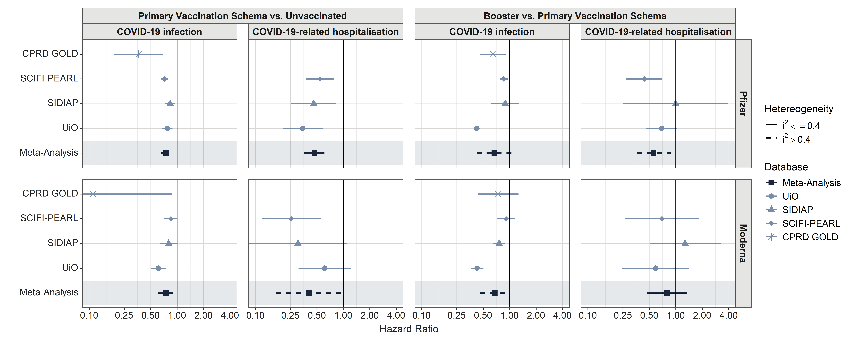

## **Appendix Figure 7:** Kaplan-Meier curves for COVID-19 infection, across databases, and analysis

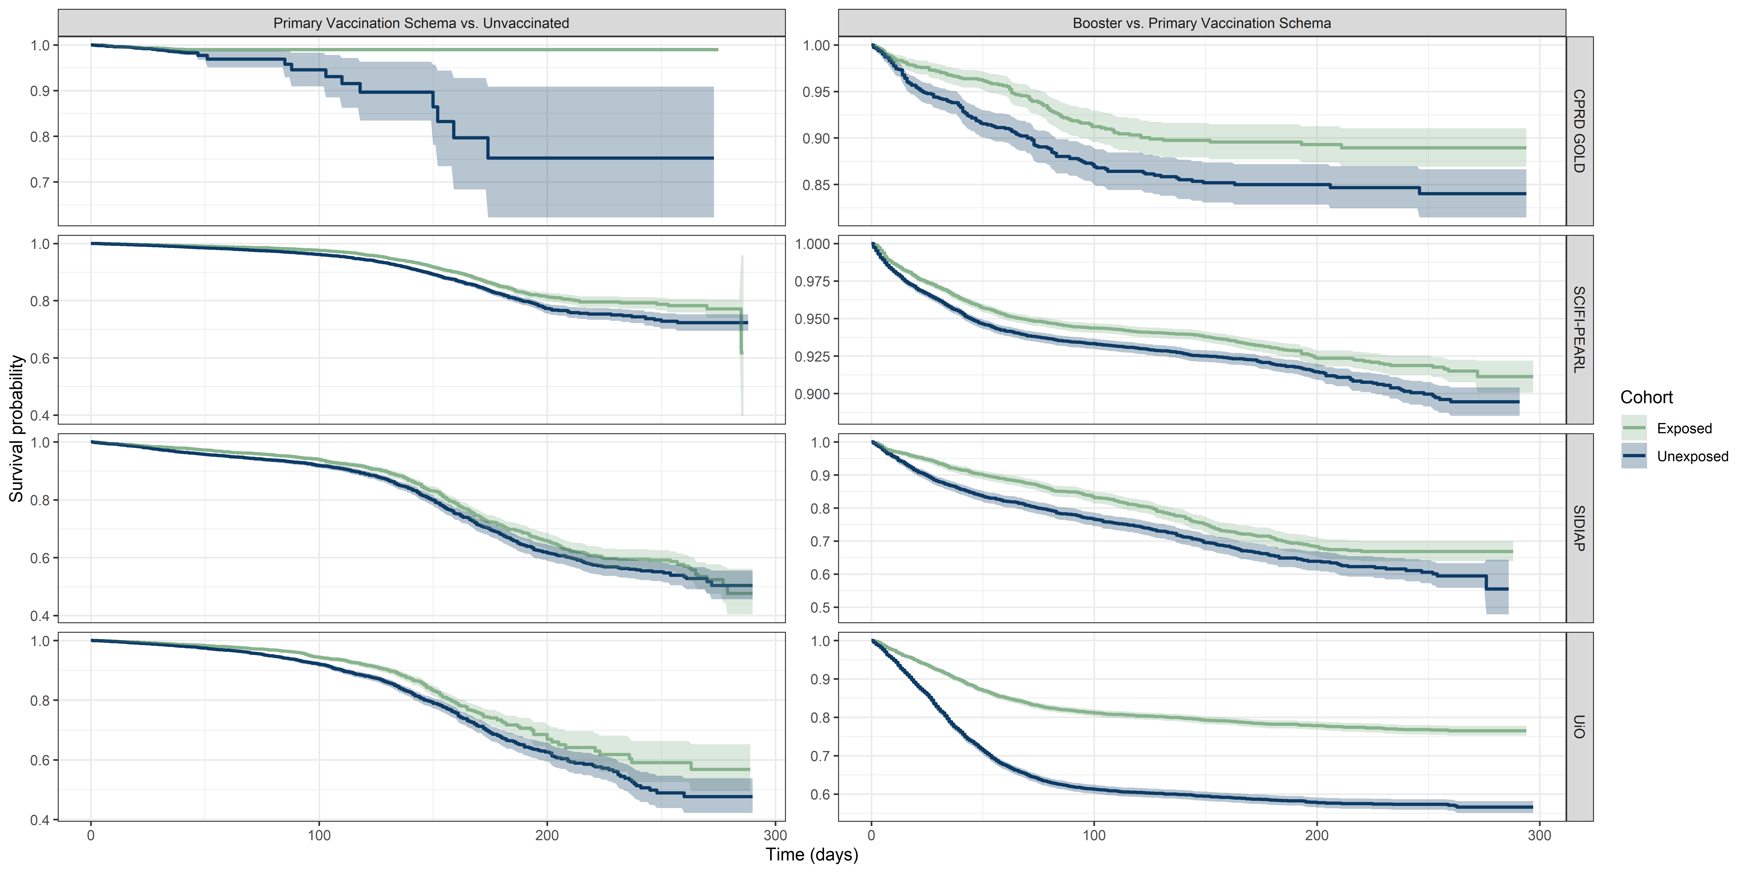

## **Appendix Figure 8:** Kaplan-Meier curves for COVID-19-related hospitalisation, across databases, and analysis

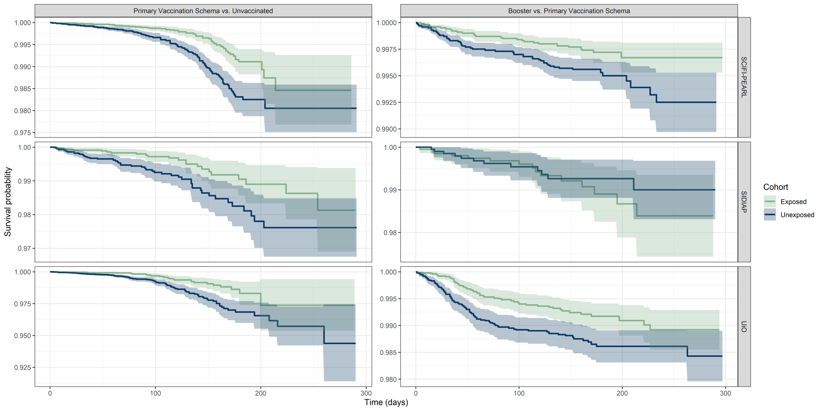

## **Appendix Figure 9:** Log-Log plots for COVID-19 infection, across databases, and analysis

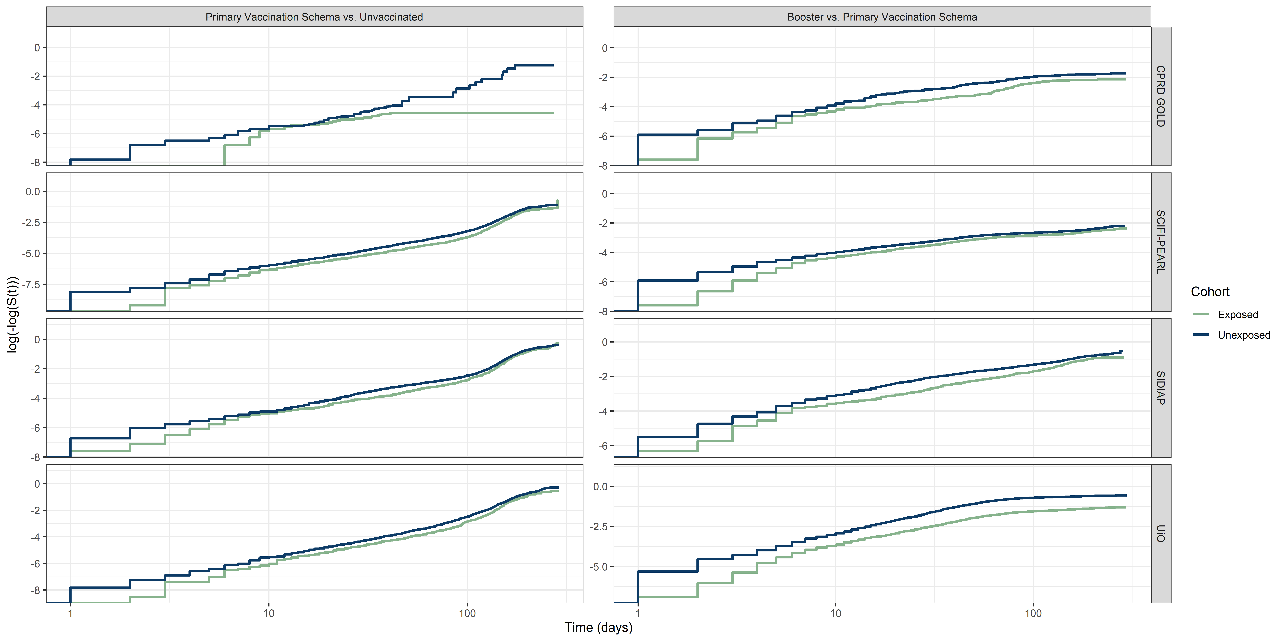

## **Appendix Figure 10:** Log-Log plots for COVID-19-related hospitalisation, across databases, and analysis

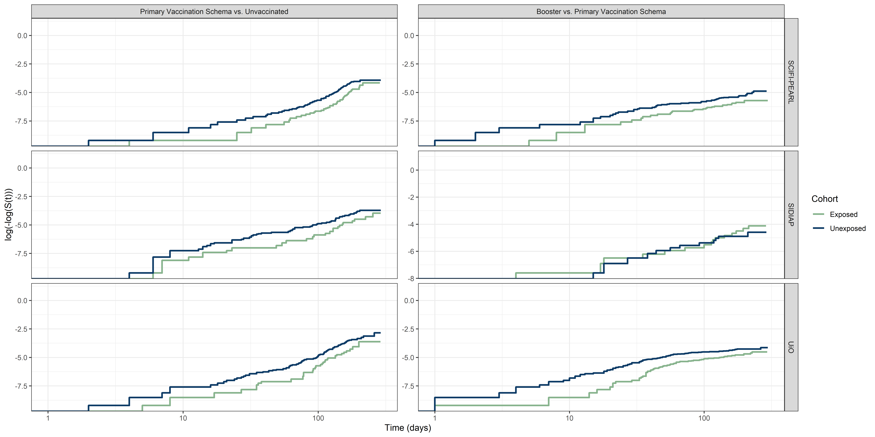

## **Appendix Figure 11:** Meta-Analysed Hazard Ratio estimates against COVID-19 infection and COVID-19 related hospitalisation across different time-windows post-vaccination.

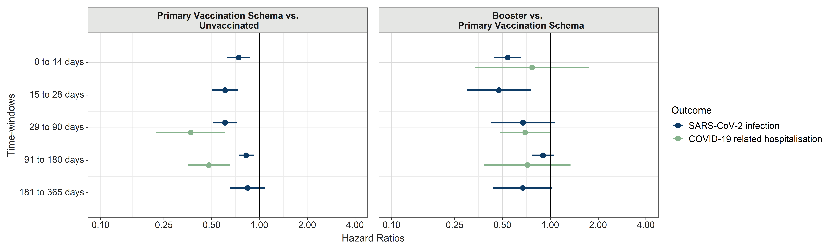

## **Appendix Figure 12:** Negative Control Outcomes results for SCIFI-PEARL database.

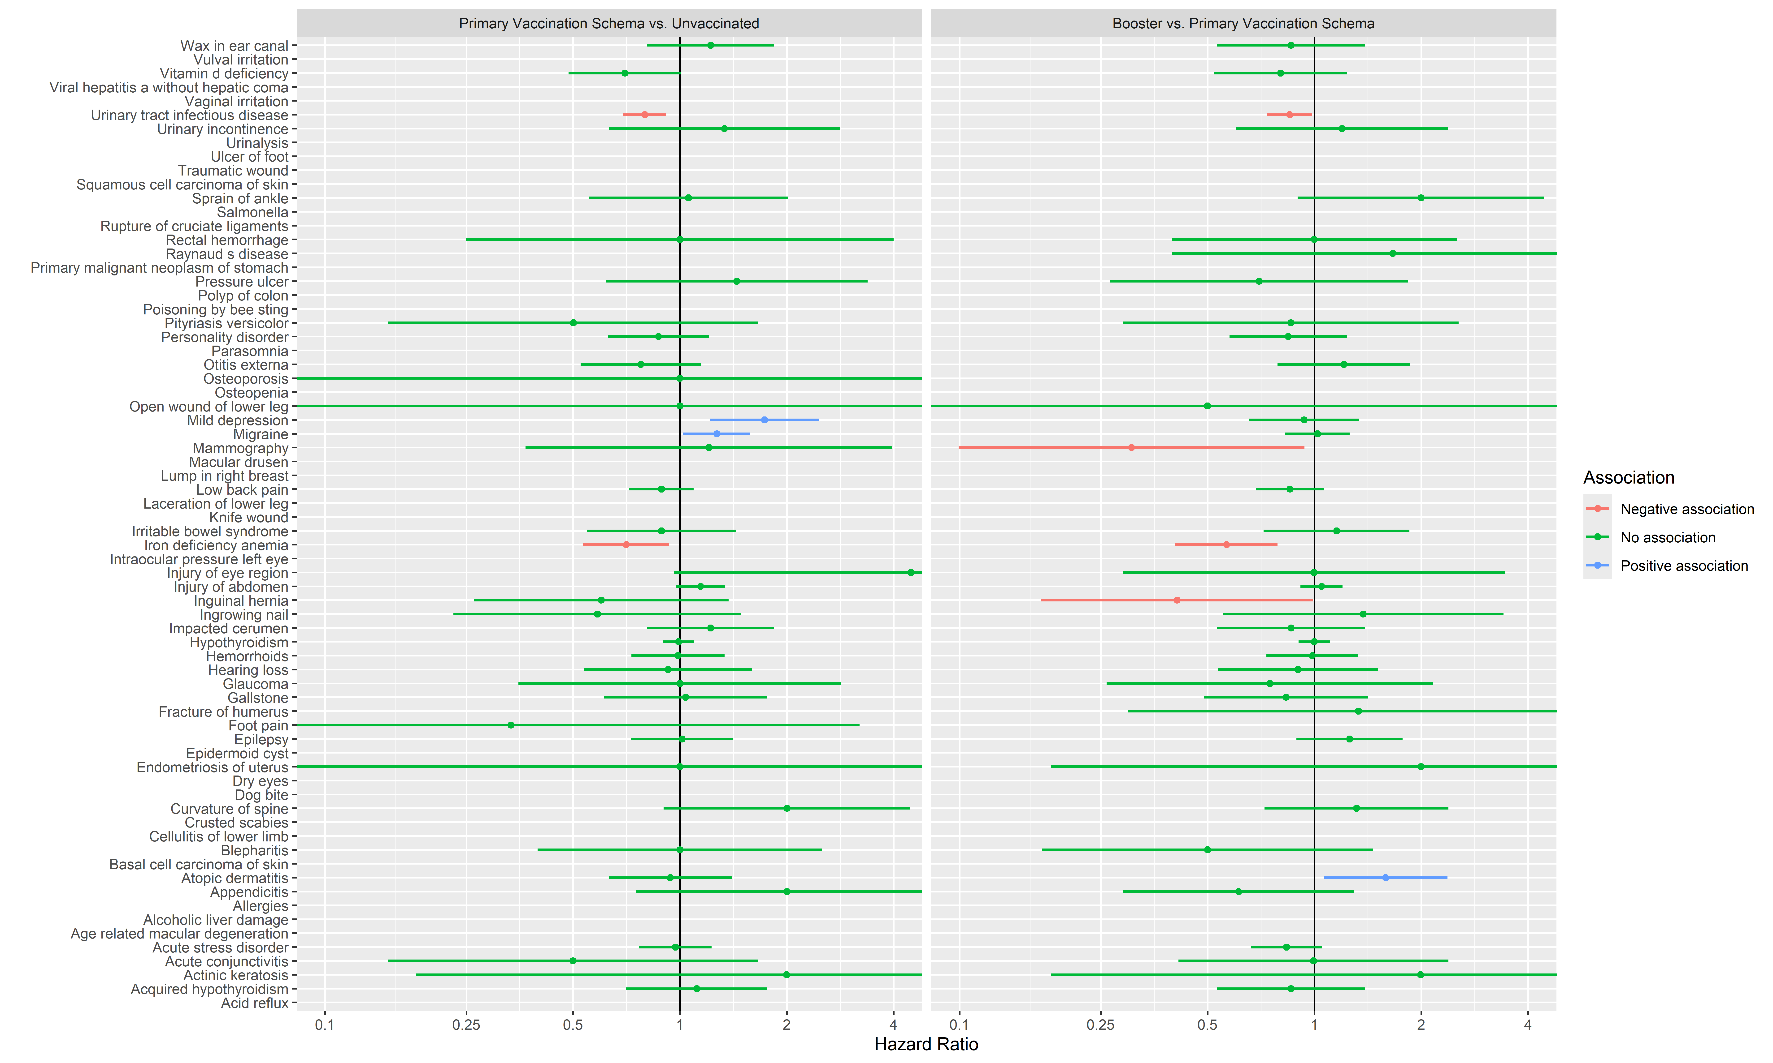

## **Appendix Figure 13:** Negative Control Outcomes results for UiO database.

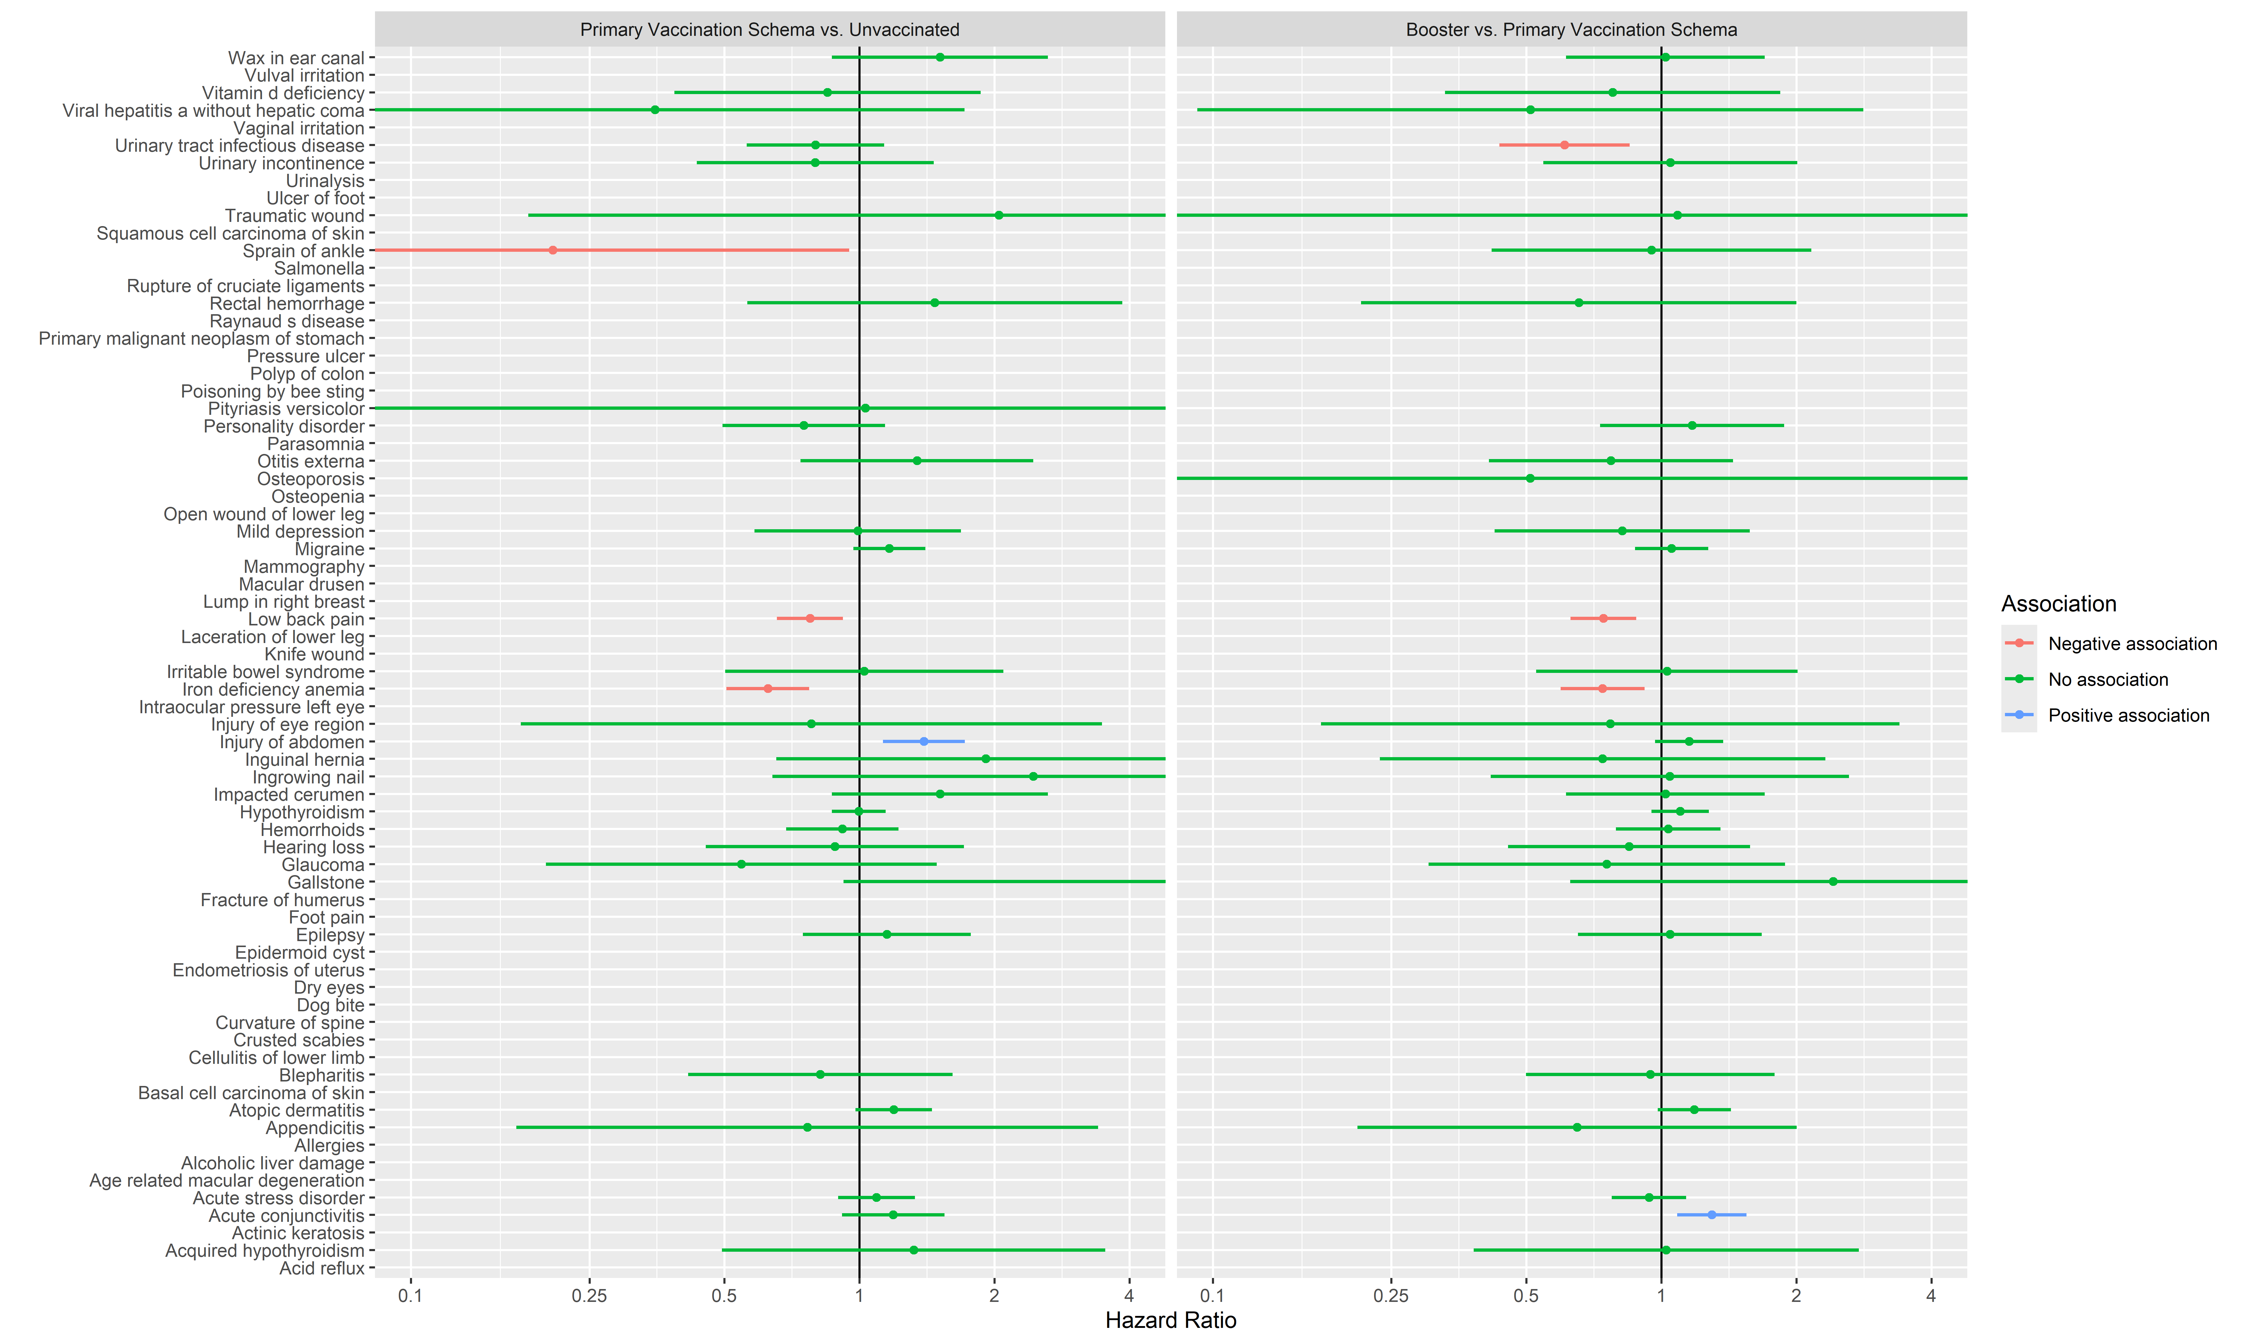

## **Appendix Figure 14:** Negative Control Outcomes results for SIDIAP database.

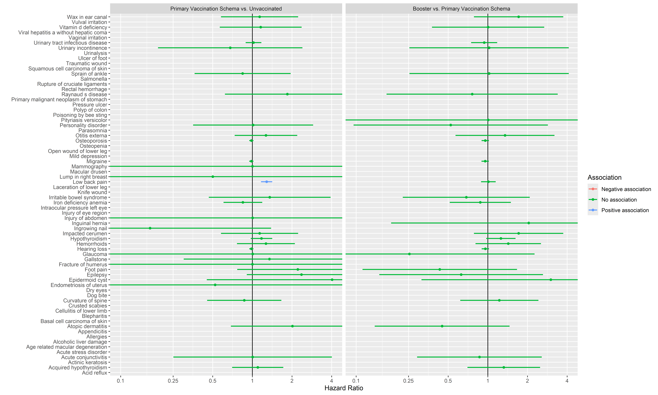

## **Appendix Figure 15:** Negative Control Outcomes results for CPRD GOLD database.

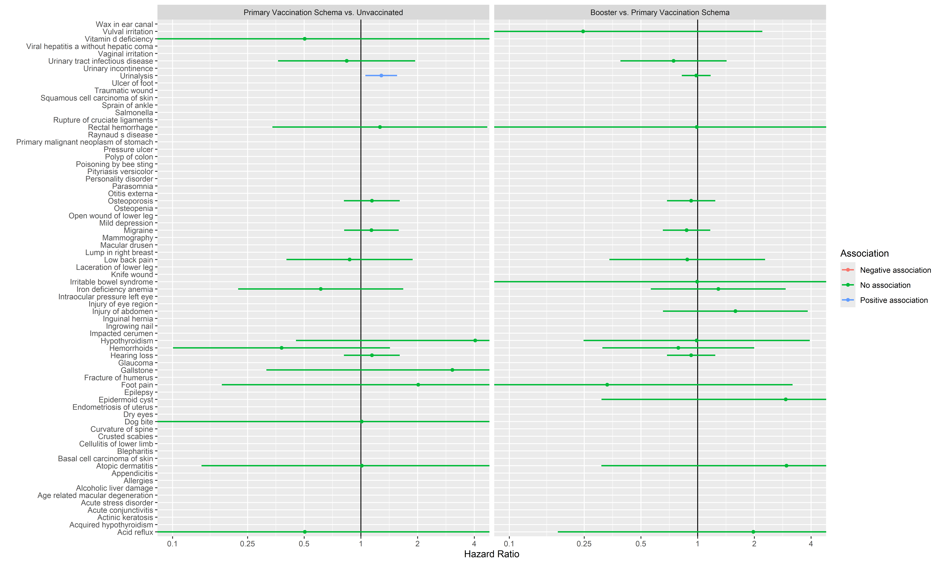

## **Appendix Figure 16:** Vaccine effectiveness estimates for Primary Vaccination Schema vs. Unvaccinated, when follow-up is not stopped at pregnancy end date.

Imatge que conté text, captura de pantalla, Font, nombre

Pot ser que el contingut generat amb IA no sigui correcte.

## **Appendix Figure 17:** Vaccine effectiveness estimates for Booster vs. Primary Vaccination Schema, when follow-up is not stopped at pregnancy end date.

Imatge que conté text, captura de pantalla, Font, nombre

Pot ser que el contingut generat amb IA no sigui correcte.

## **Appendix Figure 18:** Hazard Ratios for COVID-19 Infection and Hospitalisation (Primary Vaccination Schema vs. Unvaccinated, and Booster vs. Primary Vaccination Schema) stratified by pregnancy trimester at time of vaccination, when follow-up is not stopped at pregnancy end date.

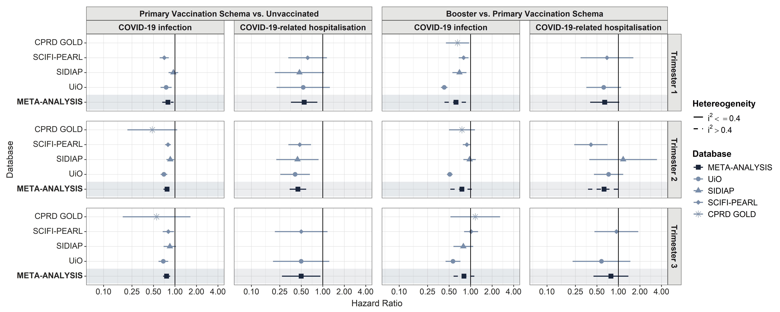

## **Appendix Figure 19:** Hazard Ratios for COVID-19 Infection and Hospitalisation (Primary Vaccination Schema vs. Unvaccinated, and Booster vs. Primary Vaccination Schema) stratified by vaccine brand, when follow-up is not stopped at pregnancy end date.

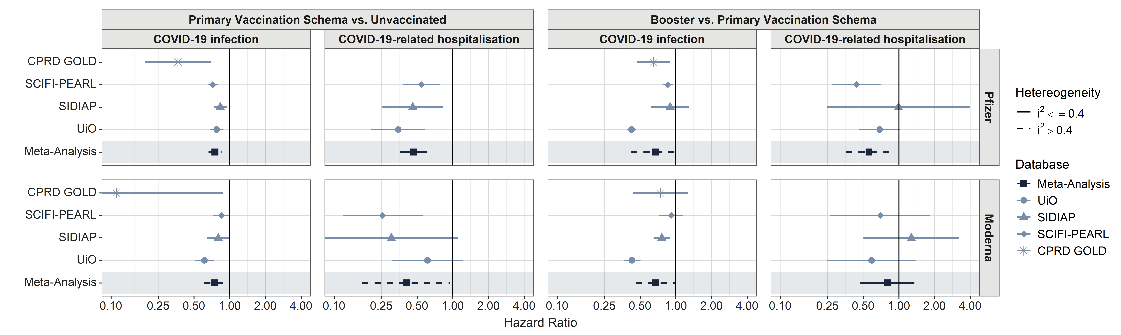

## **Appendix Figure 20:** Hazard Ratios for COVID-19 related Hospitalisation (Primary Vaccination Schema vs. Unvaccinated, and Booster vs. Primary Vaccination Schema), when hospitalisation related to delivery is considered.

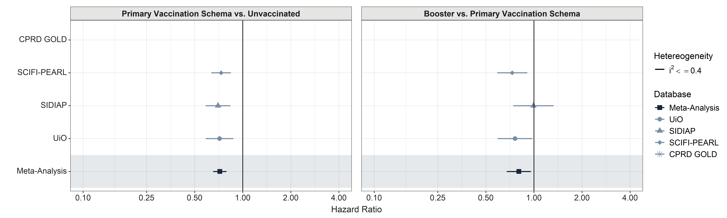

## **Appendix Figure 21:** Vaccine effectiveness estimates for Primary Vaccination Schema vs. Unvaccinated, when COVID-19 records are identified based on polymerase chain reaction (PCR) or antigen postitive tests.

Imatge que conté text, captura de pantalla, Font, nombre

Pot ser que el contingut generat amb IA no sigui correcte.

## **Appendix Figure 22:** Vaccine effectiveness estimates for Booster vs. Primary Vaccination Schema, when COVID-19 records are identified based on polymerase chain reaction (PCR) or antigen postitive tests.

Imatge que conté text, captura de pantalla, Font, nombre

Pot ser que el contingut generat amb IA no sigui correcte.